Seneca Polytechnic

TPJ655 Project Report

Spoken Code – Puzzle Game

Submitted To:
Professor Karen Craigs
TPJ655NBBL
Date:4/11/2026

Submitted By:
Ashburne Blake Gano
Jiseok Song

§ 02 Abstract

This project is an interactive two-player puzzle game designed to improve communication, teamwork, and problem-solving skills. Each player uses a separate console to participate in the game. One player, called the describer, can see the hint and explains it verbally, while the other player, called the answerer, selects the answer based only on the explanation. Communication is limited to voice, which encourages clear instructions, active listening, and cooperation.
The game is divided into multiple stages that challenge the players in different ways. These include entering numbers using a keypad, replicating patterns on a 4x4 LED display, recognizing symbols, exploring partial symbols with a joystick, and comparing similar images to spot small differences. Players must complete all stages within a set time limit and using a limited number of chances. Successfully completing the final stage unlocks an RFID key, which the answerer taps to the describer’s tag to win the round.
The system is controlled by an ESP32-S3 microcontroller, which manages all inputs, outputs, and game logic. It communicates with displays, LEDs, a buzzer, a keypad, and a stepper motor–controlled card enclosure using GPIO, SPI, and I²C protocols. A TFT display provides graphical instructions and feedback, while 4-digit TM1637 and 7-segment displays show the timer and remaining attempts. The RGB LED indicates correct or incorrect answers, and the buzzer provides sound cues for various game events.
The second console uses a stepper motor with a ULN2003 driver to control the keycard enclosure, while an MCP23017 I/O expander allows multiple inputs to be handled efficiently. Both consoles are designed to work together in real time, providing visual, audio, and physical feedback to create an engaging and interactive experience.
Overall, this project shows how hardware and software can work together to create a fun and functional game. It emphasizes the importance of accurate input processing, clear visual and audio feedback, and effective teamwork. The finished system provides an entertaining experience while demonstrating how electronics, programming, and user interface design can come together in a project.

§ 03.1 Table of Contents
§ 02 Abstract 1
§ 03.1Table of Contents 2
§ 03.2 Table of Figures 3
§04. Introduction 4
§05. Background Research & Development 5
§06. System Functional Features & Specifications 6
§07. System Design and Layout 7
§08. Hardware Components & Specifications 9
§09. Theory of Operation 13
§10. Product Operating Instructions 15
§11. Maintenance Requirements 16
§12. Future Improvements 17
§13. Conclusions: Challenges, Successes, Evidential Accuracy 18
§14. References 19
§15. Appendices 20
§15A. System Block Diagram 21
§15B. Electrical Diagrams 21
§15C. PCB Design Diagrams 22
§15D. Mechanical Design Diagrams 24
§15E. IoT Dashboard 30
31
§15F. Coding Flowchart 32
§15G. Bill of Materials 33
§15H. Contact Information 35
§15F. Full Project Software Code 36
Describer 36
1digit.h 36
4digit.h 39
4digit.cpp 39
4digitpattern.cpp 41
Buzzer.h 42
Buzzer.cpp 43
Genstage.h 45
Genstage.cpp 46
Iot_proto.h 50
Iot_proto.cpp 52
Joystick.h 61
Joystick.cpp 62
Led.h 65
Led.cpp 66
Ledpattern.cpp 67
Rfid.h 69
Rfid.cpp 70
Tft.h 73
Tft.cpp 74
Wifi_credentials.h 79
Main.cpp 80
Answerer 80
4digit.h 80
4digit.cpp 80
Buzzer.h 82
Buzzer.cpp 82
Led.h 84
Led.cpp 85
Mcp.cpp 86
Net.h 89
#ifndef NET_H 90
Net.cpp 90
Stepper.h 94
Stepper.cpp 94
Tft-client.h 97
Tft-client.cpp 98
Wifi_credentials.h 102
Wifi.cpp 102
Main.cpp 103

§ 03.2 Table of Figures
Figure 1.Logic flow for selecting the correct switch inputs in the puzzle box design (Unlock the Mystery: Puzzle Box, Jost et al., 2025) 6
Figure 2 Detailed schematics of the electronic control logic used in the puzzle system (Unlock the Mystery: Puzzle Box, Jost et al., 2025). 7

§04. Introduction

This is a puzzle game based on communication between two players. It is targeting the puzzle or board game industry for families or friends to have a great time and deepen their relationship. It also targets the education industry for kids to develop their communication and leadership skills. Each player has their own console, and only the first player (who will be called a describer) only can see the hint, and he or she must explain it in only a verbal way. The second player (who will be called an answerer) only can choose the answer based on the describer’s verbal explanation. These are specific rules and stages.
RULES
1. Two persons for each round
2. One person becomes describer and another person becomes answerer
3. Communication is permitted only by voice
4. Describer explains the answer as precise as possible, and answerer should choose the correct answer.
5. They should solve 5 questions in 5 minutes, 5 chances.
6. If 5 minutes pass or they consume 5 chances before they tap the rfid key, they fail.

Stages
1. Number displayed on digit display: keypad
2. 4x4 LED display pattern: 4x4 LED button switch
3. A symbol on the display: Choose one from 4 options on the display
4. A symbol is only shown where the pointer exists. Move the pointer with joystick to see the whole symbol: Choose one from 4 options on the display
5. Two similar pictures on the display with only a few different parts: Choose the correct combination from 4 options on the display
6. RFID shield is opened and the answerer gets rfid key.
7. If the rfid key is tapped to the describer’s rfid tag within 5 minutes, 5 chances, they win.

§05. Background Research & Development

We researched several similar projects for our project. The first one is Keep Talking and Nobody Explodes, which is a popular communication game and what we get inspired by. It needs two players for the game and only verbal explanation is allowed. One player explains the hint and another player chooses the answer (Keep Talking and Nobody Explodes, 2015). However, since it is a fully software game, it is online without physical communication. It doesn’t let people communicate in person, have more fun, and deepen their relationship. Therefore, we decided to create a game that has similar rules and stages, but as a hardware-based game to play this game in person.
The second one is A Simulation Escape Room: Verification and Validation is the Key which demonstrates an educational project to support students to learn V&V processes using escape room to debug and learn the model they created (Kuhl, 2024). The escape room has almost the same steps, and this project also has the purpose of education, which we also target for. The players can learn V&V processes while they are playing with their families or friends, and our goal is also to let players have fun and enhance their communication skills and deepen their relationship.
The third one is Unlock the Mystery: Puzzle Box. Jost et al. (2025) explained how they created an electronic puzzle box with demanding logic and hardware design that players must solve to unlock the mechanism. Their logic and processes are like our project since both projects require the players to solve the problem and if they succeed, the puzzle is unlocked. Also, as shown in figure 1, they require the players to figure out the right switch, which has the same input logic as our project stage 2 that requires the players to push right switches on 4x4 switches. Figure 2 shows the detailed schematics of their logic, which is helpful to learn how to design electronic logic for our project.
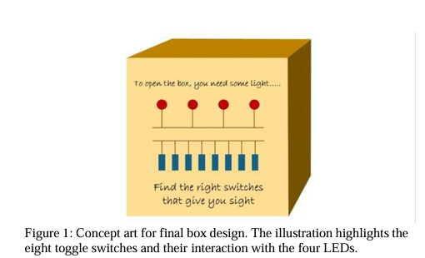
Figure 1.Logic flow for selecting the correct switch inputs in the puzzle box design (Unlock the Mystery: Puzzle Box, Jost et al., 2025)
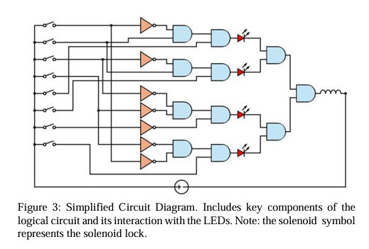
Figure 2 Detailed schematics of the electronic control logic used in the puzzle system (Unlock the Mystery: Puzzle Box, Jost et al., 2025).

§06. System Functional Features & Specifications

Roles:
- Players choose whether to relay hints or solve the puzzles
- Once the game starts, players cannot switch consoles mid-game.
Timer
- 5-minute countdown timer to finish all 5 stages
Attempts
- 5 attempts the whole game
- Each failed attempt reduces the number of attempts
Stages
- Stages get harder
- Next stage unlocks after a successfully solving the puzzle
Win/Fail
- Final stage completion opens a small enclosure with a key card
- Tapping the card on other players console is a Win
- Fail when attempts or timer run out
Visual & Audio Feedback
- Segment display shows timer
- Attempts indicator on a 7-segment display
- Correct/Incorrect alert
IOT Dashboard
- Displays leaderboard
- Closes/opens keycard enclosure manually
Control System
- Processes keypad entries, button selections, and joystick movement.
- Validates inputs and triggers system responses.

§07. System Design and Layout
The describer has 4 outputs: TFT display with no touchscreen, LED matrix, digit display, and RGB LED and 2 inputs: RFID reader and joystick. The answerer has 4 outputs: TFT display with touchscreen, digit display, RGB LED and buzzer and 3 inputs: arduino keypad, 4x4 matrix switch, and TFT display as touchscreen. When the game starts, both devices check the communication and keep checking it until wifi communication is fully reserved. Then, the game starts and players have 5 minutes and 5 chances to solve 5 stages. If they can solve 5 stages before 5 minutes pass or 5 chances are consumed, stepper motor runs and show rfid key to be tapped and finish the game. Otherwise, they fail and lose the game.

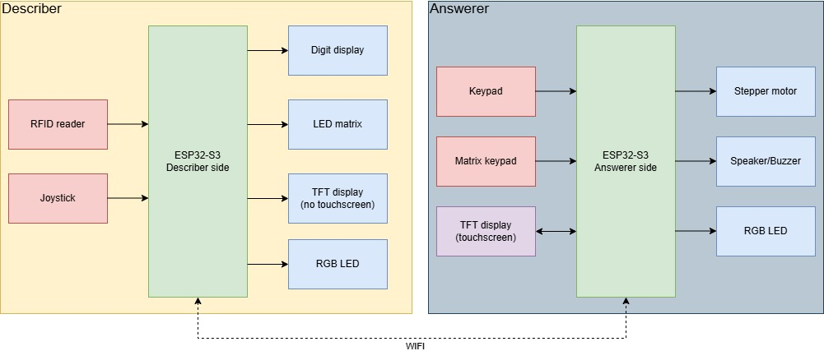
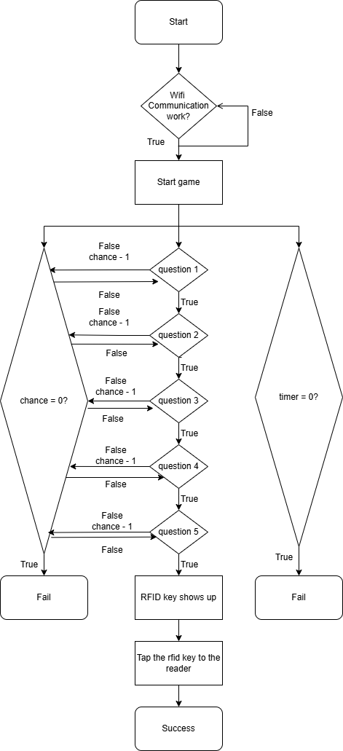

§08. Hardware Components & Specifications

Console 1:
- ESP32-S3 N16R8 MCU 44Pin ESP32S3 Type-C
- Used to control all components in the project device

- TFT LCD touch screen module SPI serial port expansion board (2.8 inches with touch)
- VCC -> 3.3V
- GND -> GND
- CS -> GPIO1
- RST -> RST
- DC -> GPIO16
- MOSI -> GPIO15
- SCK -> GPIO7
- LED -> 3.3V

- (1) 4 Digit 7 Segment RGB Display (TM1637)
- GND -> GND
- VCC -> 3.3V
- DIO -> GPIO2
- CLK -> GPIO42

- (2) 4 Digit 7 Segment RGB Display (TM1637)
- GND -> GND
- VCC -> 3.3V
- DIO -> GPIO13
- CLK -> GPIO14

- LED RGB Clear
- Pin1 -> GPIO38
- VCC -> 3.3V
- Pin2 -> GPIO37

- RC522 RFID MODULE
- GND -> GND
- VCC -> 3.3V
- RST -> GPIO35
- MISO -> GPIO45
- MOSI -> GPIO47
- SCK -> GPIO21
- SDA -> GPIO20

- Buzzer
- Cathode -> GND
- Anode -> Emitter(2n3904)
-Base(2n3904) -> 1KOhm -> GPIO17
-Collector -> 5V

- 4x4 LED Matrix
- GND -> GND
- VCC -> 5V
- IN -> 330Ohm -> GPIO18

- 7 Segment Display
- VCC -> 3.3V
- Pin1(e) -> GPIO10
- Pin2(d) -> GPIO9
- Pin4(c) -> GPIO46
- Pin6(g) -> GPIO12
- Pin7(f) -> GPIO11
- Pin9(a) -> GPIO8
- Pin10(b) -> GPIO3

- Joystick
- GND - > GND
- VCC -> 3.3V
- VRX -> GPIO4
- VRY -> GPIO5
- SW -> GPIO6

- 5V USBC
- 5V -> 5VIN
- GND -> GND

Console 2:
- ESP32-S3 N16R8 MCU 44Pin ESP32S3 Type-C
- Used to control all components in the project device
- 4 Digit 7 Segment RGB Display (TM1637)
- VCC -> 3.3V
- GND -> GND
- DIO -> GPIO1
- CLK ->GPIO2

- LED RGB CLEAR
- Pin1 -> 330Ohm Resistor -> GPIO38
- Pin2(anode) - > 3.3V
- Pin 3 -> 330Ohm Resistor -> GPIO37

- Stepper Motor (ULN2003 Driver Module with Cable)
- VCC - > 5V
- GND -> GND
- IN1 -> GPIO47
- IN2 -> GPIO21
- IN3 -> GPIO20
- IN4 -> GPIO19

- 5V-USBC
- 5V -> 5Vin
- GND ->GND

- Buzzer Magnetic 5V
- Cathode -> GND
- Anode -> Emitter(2n3904)
- Base(2n3904) -> 1KOhm -> GPIO17
- Collector -> 5V

- MCP23017 16Bit I/O Expansion Board Module Pin PCB IIC I2C Interface to GIPO Converter
- SDA -> GPIO12
- SCL -> GPIO11
- GND -> GND
- VCC -> 3.3V

- SPI TFT LCD Touch Panel Serial Port Module ILI9341 240x320 Serial LED Display (2.8-inch)
- VCC -> 3.3V
- GND -> GND
- CS -> GPIO4
- RST -> RST
- DC -> GPIO5
- MOSI -> GPIO6
- SCK -> GPIO7
- LED -> 3.3V
- MISO -> GPIO15
- T_CLK -> GPIO7
- T_CS -> GPIO16
- T_DIN -> GPIO6
- T_DO -> GPIO15

§09. Theory of Operation

The system is controlled by the ESP32‑S3 microcontroller. This MCU processes all player inputs, manages the game logic, and communicates with component devices. The ESP32-S3 uses GPIO, SPI, and I²C communication protocols to interface with the connected devices. It reads inputs from devices such as the joystick, RFID reader, keypad, and switches, then processes the information to determine the appropriate response, such as updating displays, turning on the buzzer, or driving the stepper motor to open card enclosure.
The 4-digit display shows information such as the game timer. It is controlled using the TM1637, which allows the ESP32-S3 to control the display using only two signal pins (DIO, CLK).The 7-segment display shows the number of remaining attempts. The ESP32-S3 controls each segment (a–g) through GPIO pins to form numbers by turning on specific segments (Dot excluded).
The joystick allows players to navigate or select options in the game. It records the player’s X and Y directional input, and the movement is used to control a cursor displayed on the TFT screen connected to the ESP32-S3.
The TFT display provides a graphical interface for the game. It shows instructions, puzzles, and system messages. The display communicates with the ESP32-S3 using SPI, allowing the microcontroller to send graphics and receive touch inputs from the screen.
The RGB LED provides visual feedback for game events. Each color channel is connected to a GPIO pin through a resistor. Controlling voltage that is applied to each gpio channel will produce different colors like red for incorrect option and green for correct option.
Buzzer provides audible feedback to the players. Since the GPIO pins of the ESP32-S3 cannot supply enough current to drive the buzzer directly, a 2N3904 is used as a switching transistor. When the GPIO output goes HIGH, a small current flows through the base resistor into the transistor, turning it on. This allows current from the 5 V supply to flow through the buzzer, causing it to produce sound. There are different sounds for every event like when answer is correct/wrong or tapping card to the reader to verify successfully completing the game.
The keycard enclosure is controlled using a Stepper motor driven by a ULN2003 module. The ESP32-S3 sends a sequence of digital signals to the driver inputs (IN1–IN4). The ULN2003 strengthens these signals and activates the motor coils in order, causing the stepper motor to rotate in precise steps. In this system, the motor rotates to unlock the enclosure when the final stage is completed, and it can also be controlled by the IoT dashboard to open or close the enclosure.

MCP23017 is used to interface both 4x4 keypad and 4x4 switch module with only 2 pins. I2C communication needs only SCL and SDA connection to transmit or receive from 16 IOs. As both 4x4 keypad and 4x4 switch needs 8 ports to express coordinate (4 for each x,y axis), one mcp23017 board can receive signals from both. It provides port A lines and port B lines (8 for each) and acts like a voltage comparator that reads a line of binary signal. (Soldered Electronics, n.d.)
The 4x4 keypad and 4x4 switch module basically have the same structure except for the switch shape. All switches are connected to each axis pin they locate, and pressing a button connects to the circuit and current flows. (Pattabiraman, 2017) Therefore, it needs 8 pins for each module so that 16 pins are needed for 2 modules.

§10. Product Operating Instructions

Setup
- Place the Describer Console and Answerer Console on a table facing away from each other.
- Power on both consoles.
- Wait for system synchronization confirmation (start screen appears on both devices).
- Make sure only verbal communication is possible between players.
Objective
Both players work together to solve all puzzles using only verbal communication. Complete all stages and authenticate the RFID card obtained before the timer or attempts run out.

Gameplay Stages
- Enter the correct pin
- Recreate LED pattern
- Choose the correct symbol
- Reveal hidden symbol using joystick
- Find the correct difference

Rules
- Communication by voice only
- Do not swap consoles, only allowed when the game finishes

§11. Maintenance Requirements
Use a phillips screwdriver to depart the top and bottom side of the console. Answerer console will have one more layer since the 4x4 switch and arduino keypad do not have holes to fix it. Except these two devices, buzzer, and led, all other devices are fixed with screw and can be repaired or replaced properly with the screwdriver. If a connection issue is suspected in the pcb, get rid of screws and use dmm for testing connection. If the microcontroller has an issue or the code needs to be uploaded, never power the console and connect to the computer via usb c connector at the same time since it will damage the microcontroller. Connectors on pcb must be connected to the exact device as described in the electronic/mechanical diagrams, or it can damage the device. After maintenance, be sure to put all devices in the right place with properly tightening the screw back.

§12. Future Improvements

There are several ways we can improve the system in the future. One important improvement is making the connection between components faster and more reliable. This would help the system respond more quickly to user inputs and reduce delays during gameplay. Using better connectors or improving the communication protocols could make data transfer smoother and more efficient.
Another improvement is adding a rechargeable battery. This would allow the device to be used without being constantly plugged in, making it more portable and convenient. A battery level indicator would let users know how much power is left, and visual or audio indicators could show when the system is charging or fully charged.
The IoT dashboard could also be upgraded. Adding more features and controls would make it easier to interact with the system. For example, real-time updates, alerts, and monitoring tools would help users manage the device better. A better dashboard layout would also improve the overall user experience.
Hardware improvements could include using a better TFT display for clearer and more responsive visuals. The stepper motor mechanism could also be improved for quieter and smoother operation. The enclosure could be redesigned instead of a simple rectangular box. A more creative design would make the system look more appealing and easier to use.
Finally, the gameplay itself could be expanded. Adding more puzzles and extra levels would make the game more interesting and challenging. Different difficulty modes could be included to provide a greater challenge for experienced players. Sound feedback could also be improved with a small speaker that plays multiple tones or effects.
Another improvement is adding basic safety and error-handling features. For example, the system could check if inputs from the keypad, joystick, or RFID reader are valid before acting on them. This would prevent the system from responding incorrectly to accidental or wrong signals. A manual override for the enclosure could also be added, so the card holder can be opened by hand if the motor or electronics fail. These features would make the system more reliable and reduce the chances of it getting stuck or malfunctioning.
Overall, these improvements would make the system more functional, fun, and user-friendly. They would enhance both the hardware and software while providing a better experience for anyone playing the game.

§13. Conclusions: Challenges, Successes, Evidential Accuracy
The main challenge for the hardware design is to find a way to fit the devices securely. Most of the devices have their own way for connector pins and holes. Since they have these in different places, it is challenging to find a way to securely fix and connect these devices. For the coding part, since esp32 is microcontroller, everything runs in a loop, so it can easily miss the timing and go into the endless loop and hard to debug when it’s going wrong.
Testing the TFT display was also challenging. The display we used required a different driver than the one described in the documentation, which required adjustments in the code to make it work correctly. Additionally, the 3D models of the enclosure needed multiple revisions. Some holes were too small or too large, and certain smaller holes did not print properly, so the models had to be redesigned and reprinted multiple times to ensure everything fit correctly.

§14. References

Steel Crate Games. (2015). Keep Talking and Nobody Explodes [Video game]. Steel Crate Games.
Kuhl, M. E. (2024, April). A simulation escape room: Verification and validation is the key. Paper presented at the 2024 ASEE St. Lawrence Section Annual Conference, York University, Toronto, Ontario, Canada.
Soldered Electronics. (n.d.). MCP23017 – How it works. https://oldshop.soldered.com/documentation/mcp23017/how-it-works/
Circuit Basics. (2017, July 12). How to set up a keypad on an Arduino. https://www.circuitbasics.com/how-to-set-up-a-keypad-on-an-arduino/
OpenAI. “ChatGPT.” ChatGPT, OpenAI, 2025, chatgpt.com/

Digi‑Key Electronics. Digi-Key Electronics Canada. Digi-Key Electronics, https://www.digikey.ca/

GitHub. GitHub. GitHub, Inc., https://github.com/

‌

§15. Appendices

§15A. System Block Diagram

§15B. Electrical Diagrams
Describer:
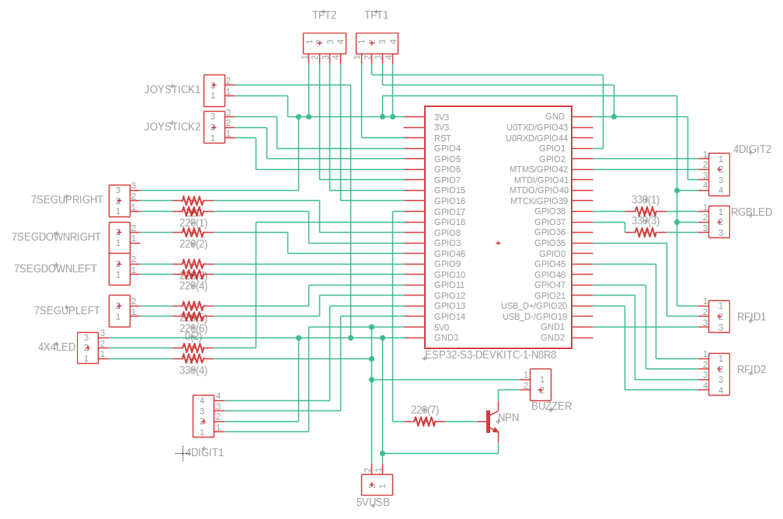
Answerer:
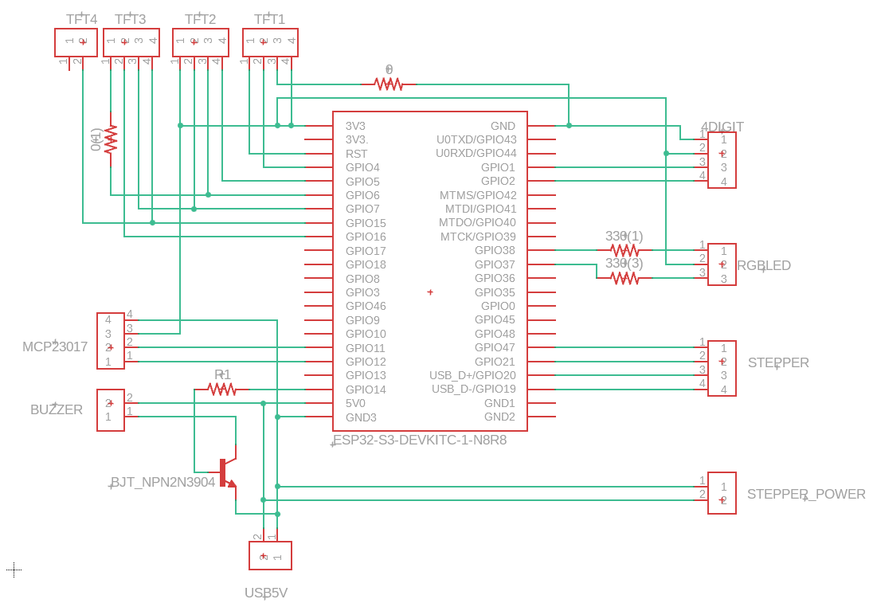

§15C. PCB Design Diagrams
Describer: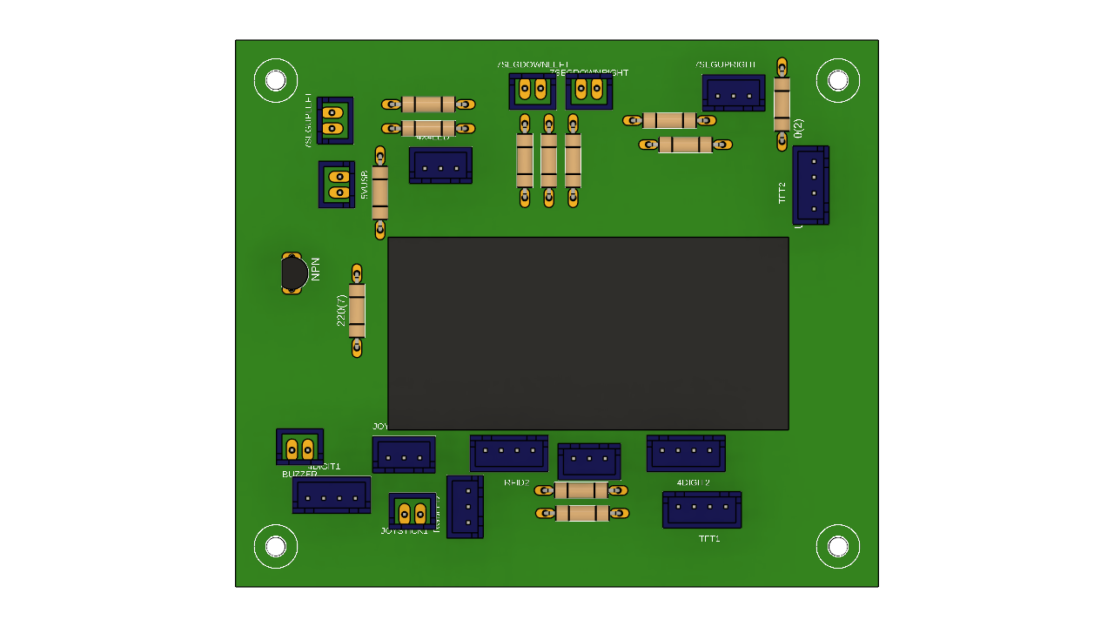
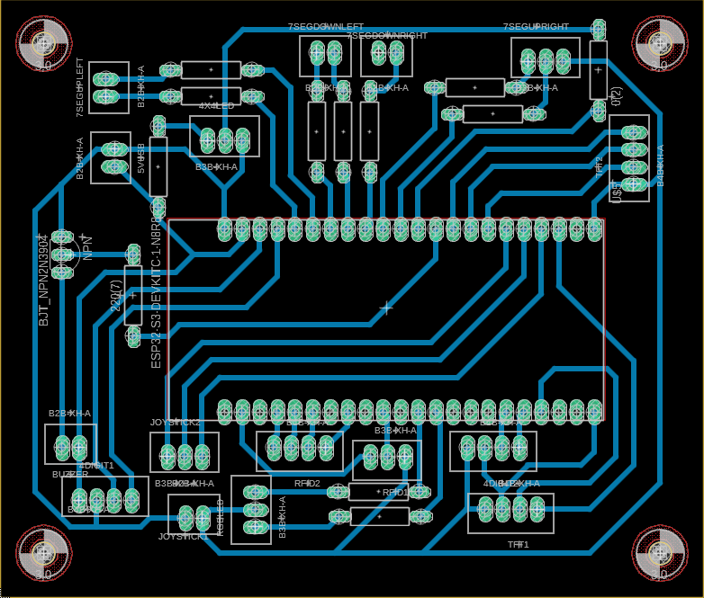
Answerer:

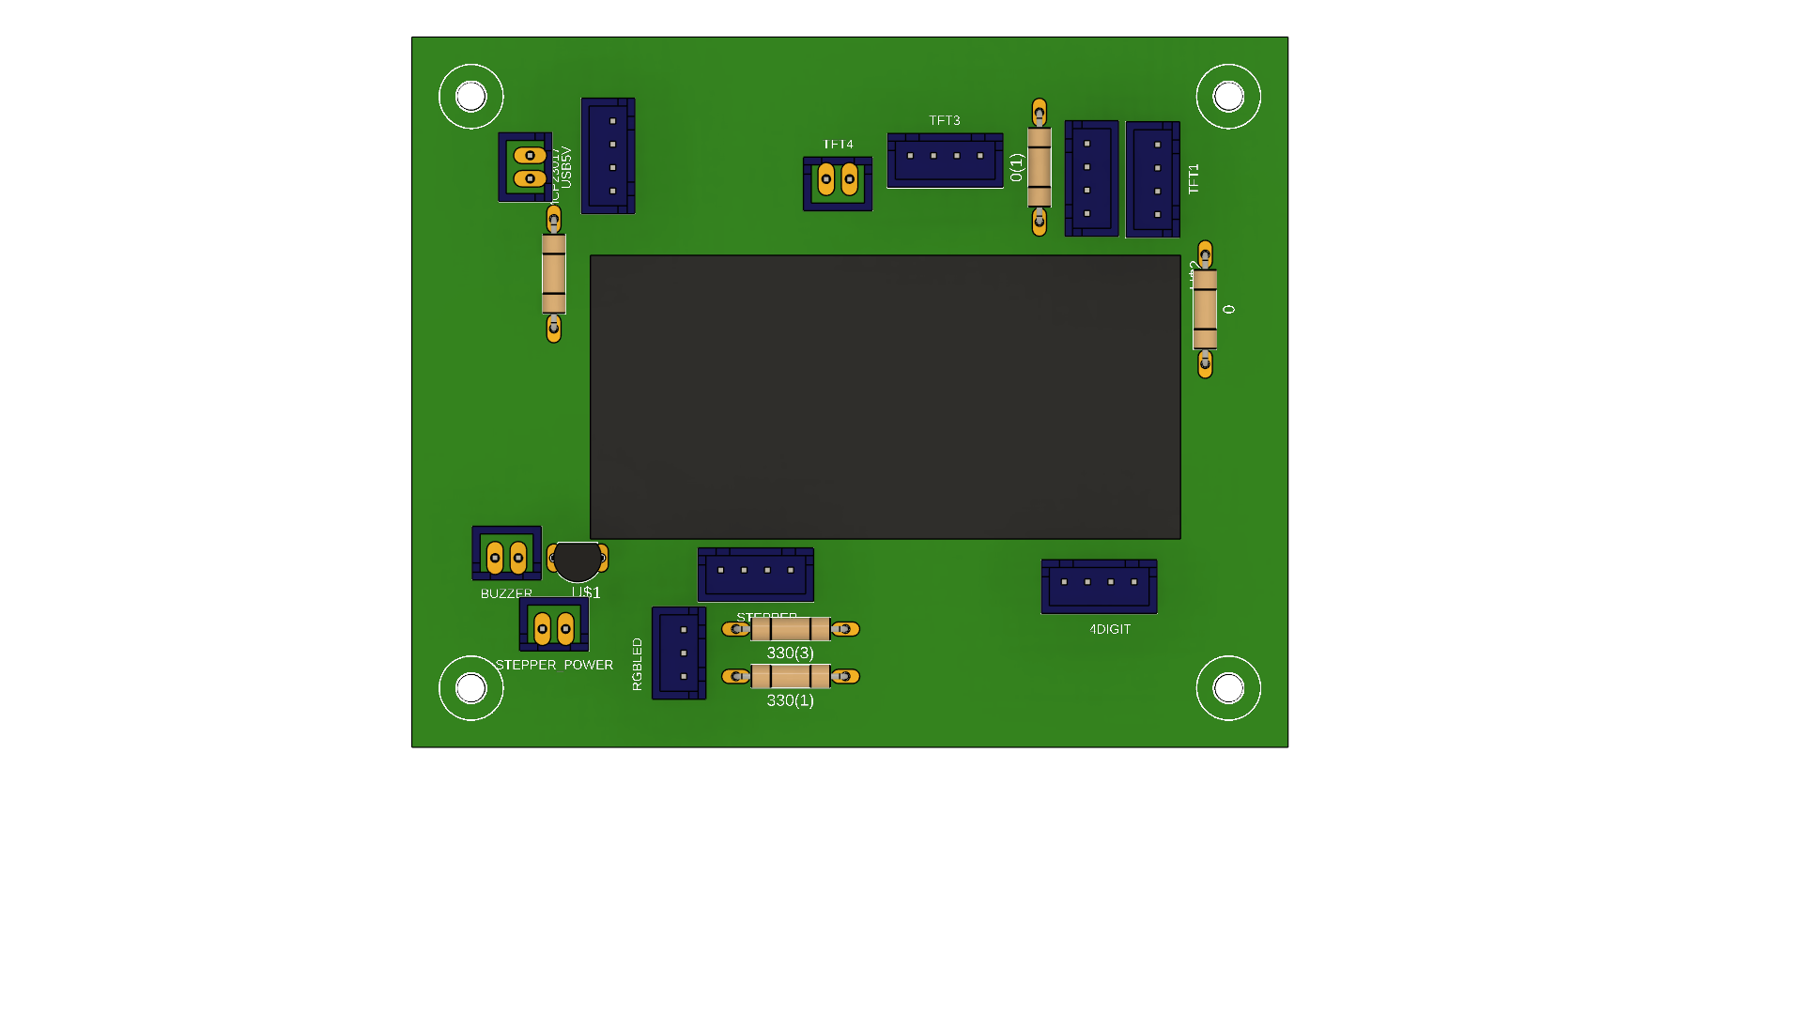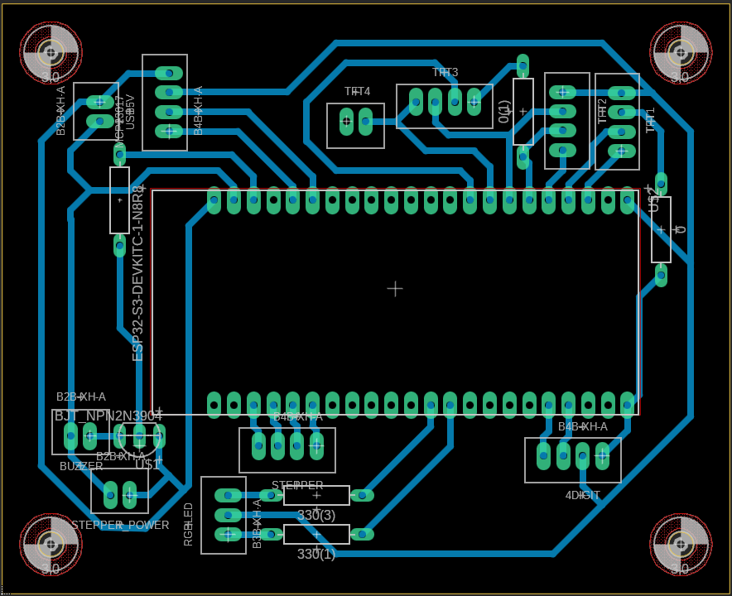

§15D. Mechanical Design Diagrams
Describer:
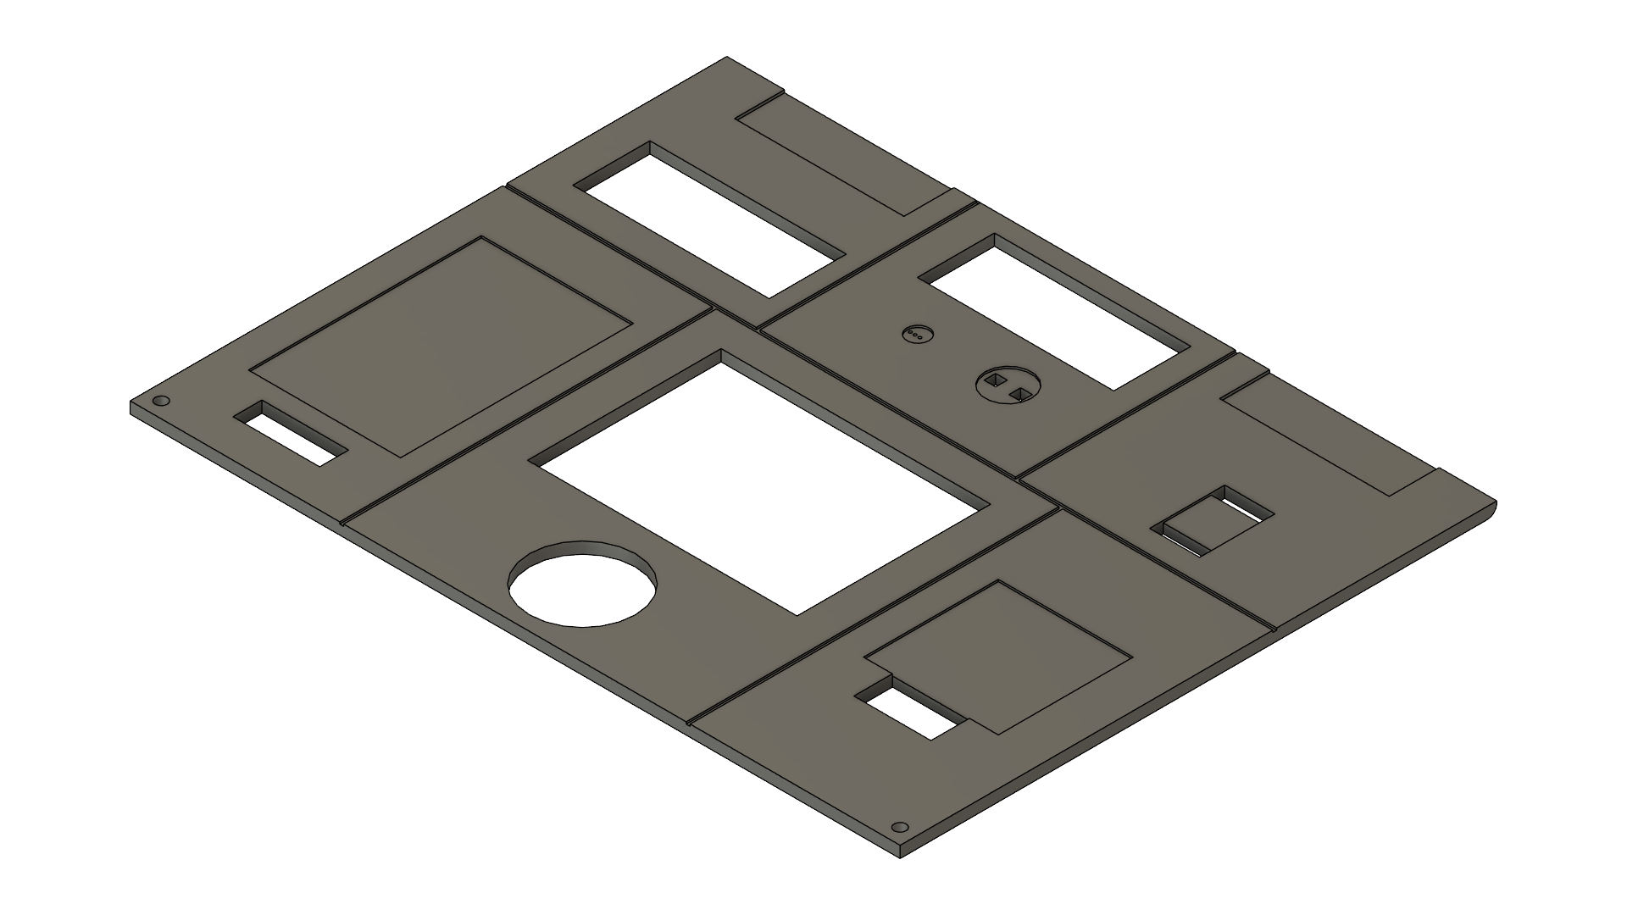
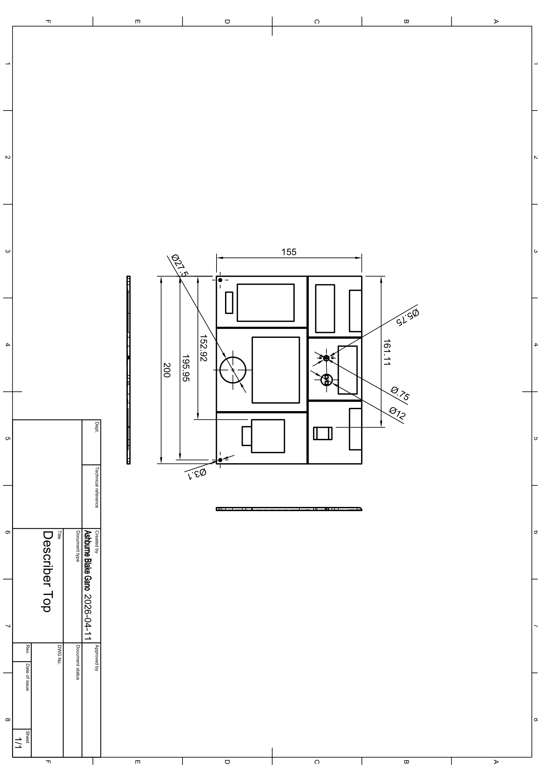
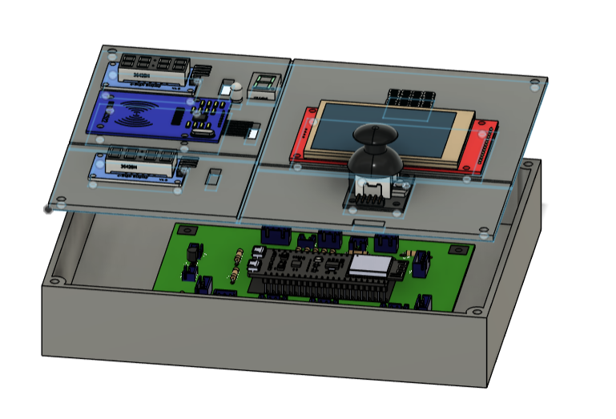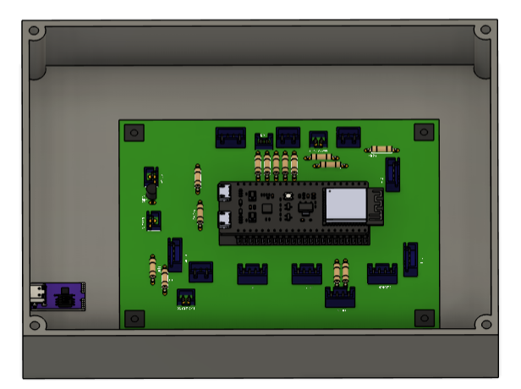

Answerer:
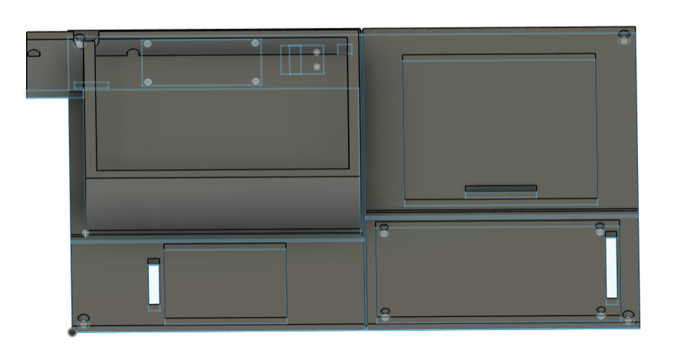
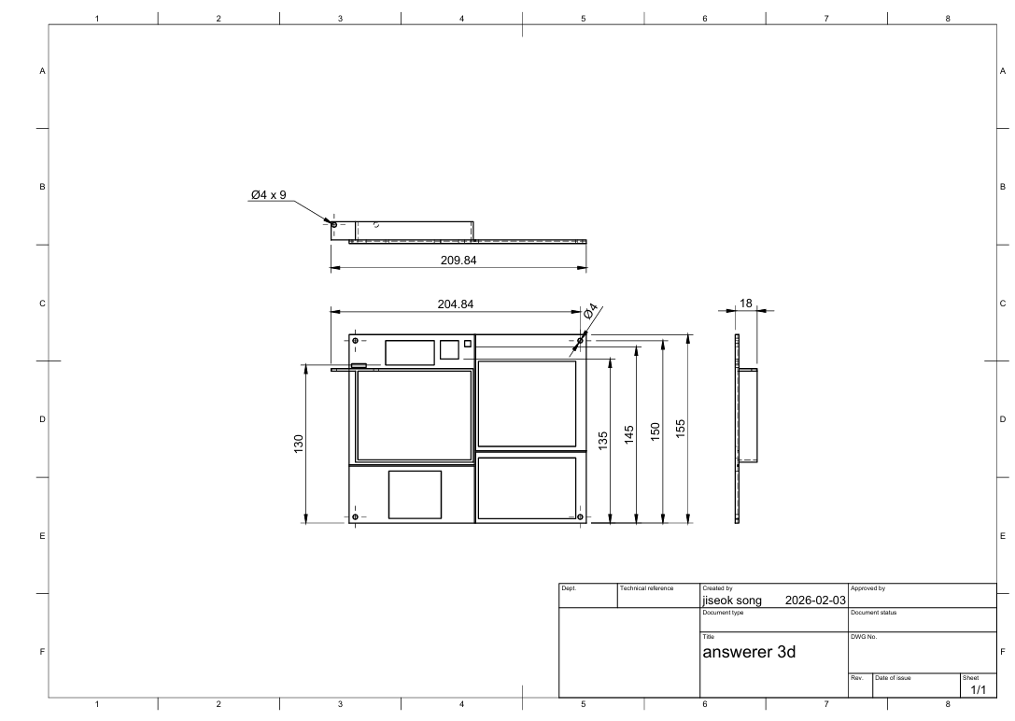
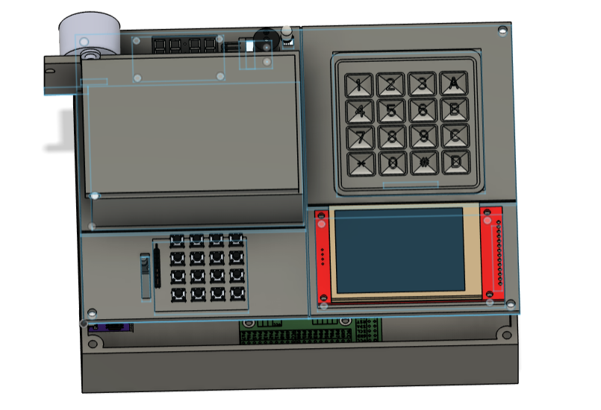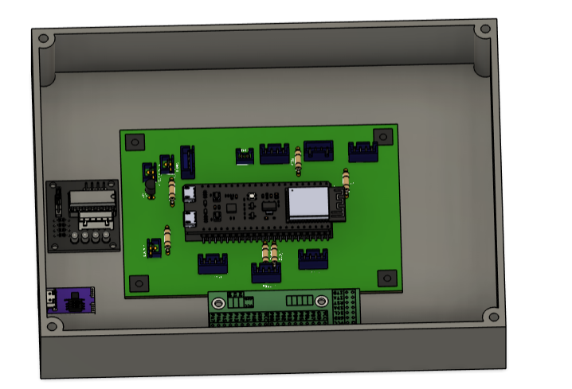

Bottom:
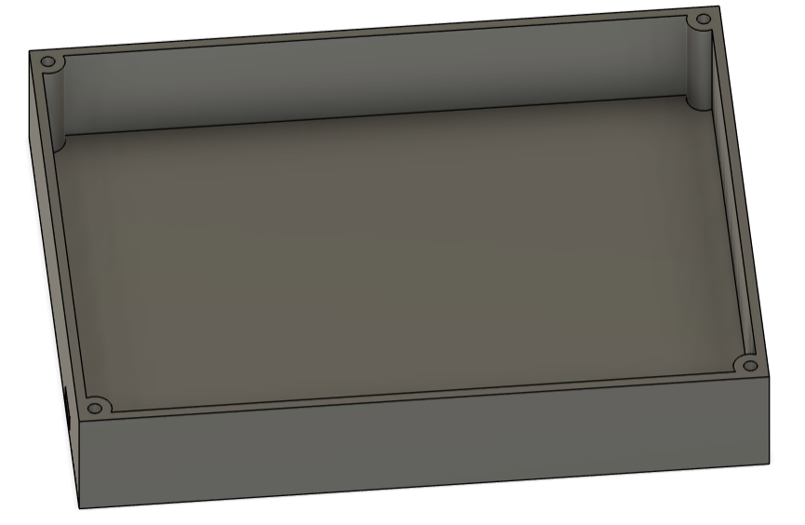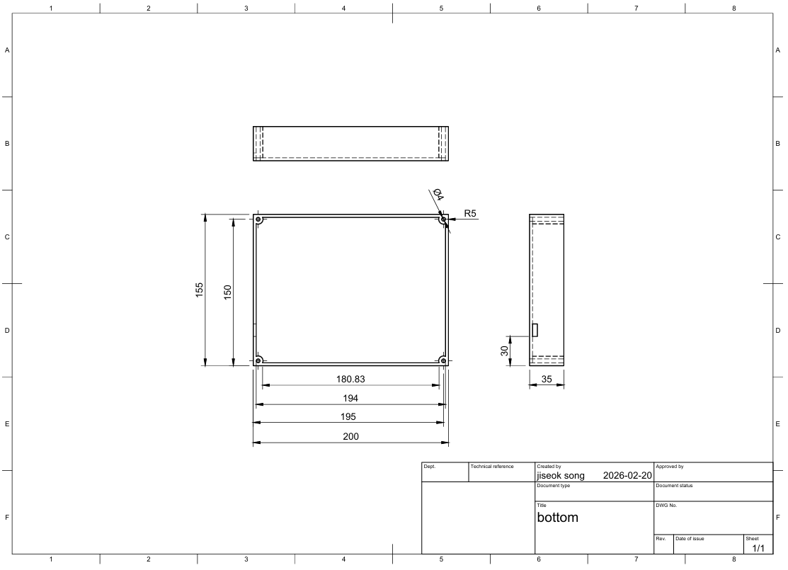
shaft:
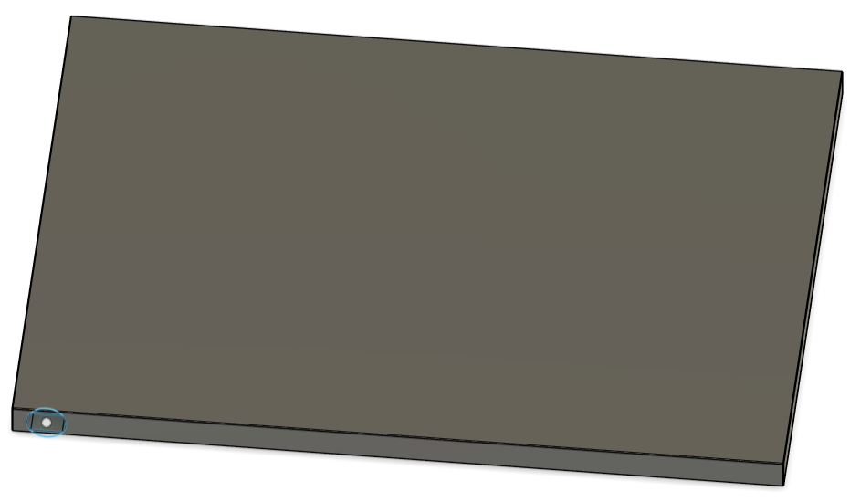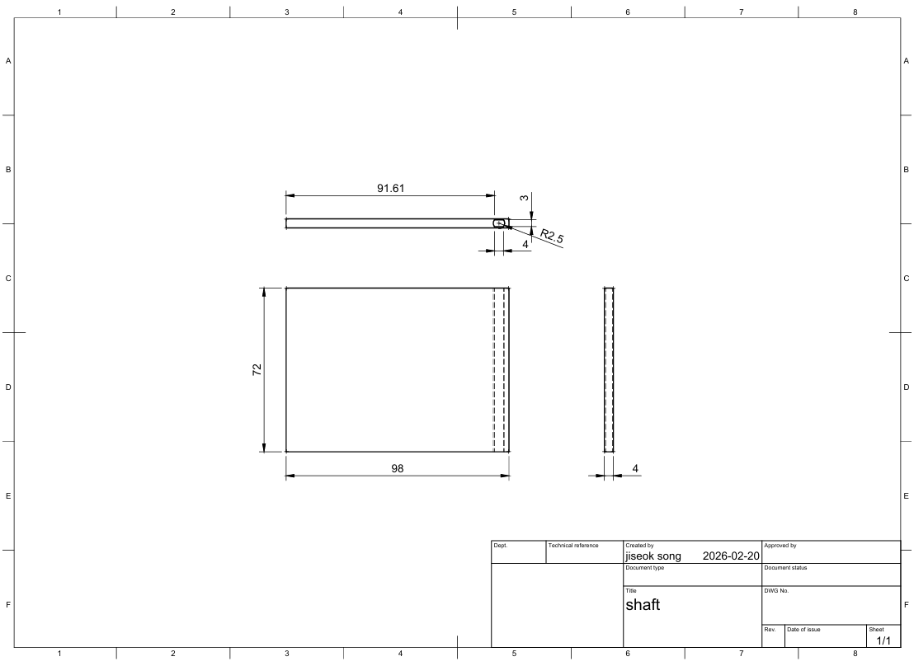

§15E. IoT Dashboard

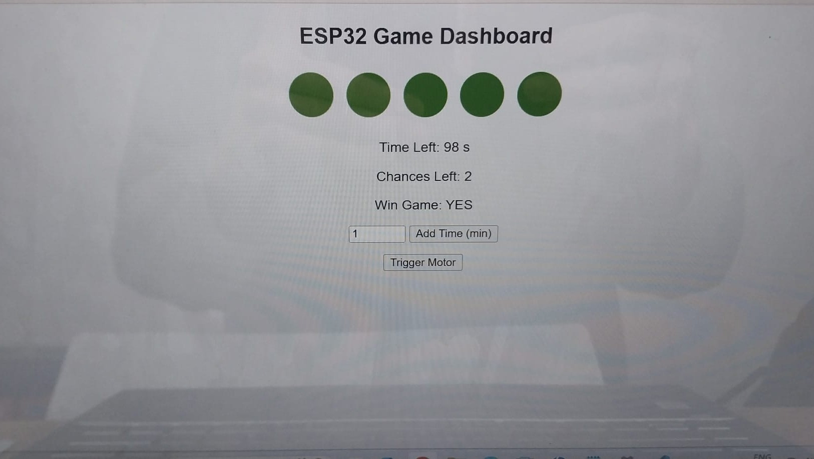§15F. Coding Flowchart

§15G. Bill of Materials

Index | Item Name | Manufacturer | Qty | $ / item | $ total | Index | Supplier | Link to Datasheet
1 | ESP32-S3-DEVKITC-1-N8R8 | SANXIXING | 2 | $23.12 | $46.24 | 1 | Digikey | https://docs.espressif.com/projects/esp-dev-kits/en/latest/esp32s3/esp-dev-kits-en-master-esp32s3.pdf
2 | 4x4 Matrix Membrane Keypad | Parallax Inc. | 1 | $14.43 | $14.43 | 2 | Digikey | https://cdn.sparkfun.com/assets/f/f/a/5/0/DS-16038.pdf
3 | Joystick Sensor Dual Axis | VKLSVAN | 1 | $15.09 | $15.09 | 3 | Amazon | https://naylampmechatronics.com/img/cms/Datasheets/000036%20-%20datasheet%20KY-023-Joy-IT.pdf
4 | Button Switch20PK | Adafruit Industries LLC | 1 | $3.85 | $3.85 | 4 | Digikey | https://cdn-shop.adafruit.com/datasheets/B3F-1000-Omron.pdf
5 | RFID Reader Module | SunFounder | 1 | $8.10 | $8.10 | 5 | Digikey | https://mm.digikey.com/Volume0/opasdata/d220001/medias/docus/60/CN0090%20DATASHEET.pdf
6 | 4-Digit Display | Seeed Technology Co., Ltd | 1 | $10.02 | $10.02 | 6 | Digikey | https://mm.digikey.com/Volume0/opasdata/d220001/medias/docus/880/Grove_4_Digit_Display_Web.pdf
7 | 7 Segment digit display | ‎ PATIKIL | 1 | $1.60 | $1.60 | 7 | Amazon | https://components101.com/displays/7-segment-display-pinout-working-datasheet
8 | RGB LED Matrix 4x4 | UNIVERSAL-SOLDER Electronics | 1 | $11.90 | $11.90 | 8 | Amazon | https://handsontec.com/dataspecs/display/WS2812%20Neopixel%204x4%20Matrix.pdf
9 | BUZZER | TDK Corporation | 1 | $0.88 | $0.88 | 9 | Digikey | https://product.tdk.com/en/system/files/dam/doc/product/sw_piezo/sw_piezo/piezo-buzzer/catalog/piezoelectronic_buzzer_ps_en.pdf
10 | Stepper Motor | Reland Sun | 1 | $5.59 | $5.59 | 10 | Amazon | https://www.ti.com/lit/ds/symlink/uc3717a.pdf
11 | RGB LED | Kingbright | 1 | $2.98 | $2.98 | 11 | Digikey | https://www.kingbrightusa.com/images/catalog/SPEC/WP154A4SEJ3VBDZGC-CA.pdf
12 | TFT Display(With Touch) | GOSEK | 2 | $19.35 | $38.70 | 12 | Amazon | https://cdn.sparkfun.com/assets/6/d/3/5/b/4DLCD-24320240-IPS-V1.0-update20190103-1608318.pdf
13 | mcp23017 ic | Microchip Technology | 1 | $1.62 | $1.62 | 13 | Digikey | https://ww1.microchip.com/downloads/aemDocuments/documents/APID/ProductDocuments/DataSheets/MCP23017-Data-Sheet-DS20001952.pdf
14 | 12V voltage supply | ShenZhen ZuoEn Technologies Co. Ltd | 1 | $12.99 | $12.99 | 14 | Amazon | https://www.shoprbc.com/images/products/rbc_icecat/_documents_/984/mmo_34606984_1493813060_549_14608.pdf
15 | Buck Converter | ‎ Acridine | 1 | $15.19 | $15.19 | 15 | Amazon | https://www.analog.com/media/en/technical-documentation/data-sheets/lt1173.pdf
16 | TFT Display(Without Touch) | YOURRYONG | 1 | $17.73 | $17.73 | 16 | Amazon | https://cdn.sparkfun.com/assets/6/d/3/5/b/4DLCD-24320240-IPS-V1.0-update20190103-1608318.pdf

§15H. Contact Information

§15F. Full Project Software Code

Describer

1digit.h
#ifndef ONEDIGIT_H
#define ONEDIGIT_H

#include <Arduino.h>

// =====================================================
// SHARED GAME STATE
// =====================================================

// Remaining chances (shared with main game logic)
extern volatile int chancesLeft;

// =====================================================
// FUNCTION DECLARATIONS
// =====================================================

// 1-digit display lifecycle
void onedigitsetup();
void onedigitloop();

#endif
1digit.cpp
#include <Arduino.h>
#include "1digit.h"

// =====================================================
// PIN DEFINITIONS (7-SEGMENT DISPLAY)
// =====================================================
#define SEG_A 8
#define SEG_B 3
#define SEG_C 46
#define SEG_D 9
#define SEG_E 10
#define SEG_F 11
#define SEG_G 12

// =====================================================
// DIGIT SEGMENT MAP (COMMON ANODE)
// LOW = Segment ON
// HIGH = Segment OFF
// Each row represents a digit (0–9)
// Order: A, B, C, D, E, F, G
// =====================================================
const uint8_t digits[10][7] = {
{LOW, LOW, LOW, LOW, LOW, LOW, HIGH}, // 0
{HIGH, LOW, LOW, HIGH, HIGH, HIGH, HIGH}, // 1
{LOW, LOW, HIGH, LOW, LOW, HIGH, LOW}, // 2
{LOW, LOW, LOW, LOW, HIGH, HIGH, LOW}, // 3
{HIGH, LOW, LOW, HIGH, HIGH, LOW, LOW}, // 4
{LOW, HIGH, LOW, LOW, HIGH, LOW, LOW}, // 5
{LOW, HIGH, LOW, LOW, LOW, LOW, LOW}, // 6
{LOW, LOW, LOW, HIGH, HIGH, HIGH, HIGH}, // 7
{LOW, LOW, LOW, LOW, LOW, LOW, LOW}, // 8
{LOW, LOW, LOW, LOW, HIGH, LOW, LOW} // 9
};

// =====================================================
// GLOBAL VARIABLES
// =====================================================
int lastDisplayed = -1; // Stores last shown digit (prevents flicker)
volatile int chancesLeft = 5; // Remaining chances (shared across modules)

// =====================================================
// SETUP FUNCTION
// Initializes all segment pins as OUTPUT
// =====================================================
void onedigitsetup() {
pinMode(SEG_A, OUTPUT);
pinMode(SEG_B, OUTPUT);
pinMode(SEG_C, OUTPUT);
pinMode(SEG_D, OUTPUT);
pinMode(SEG_E, OUTPUT);
pinMode(SEG_F, OUTPUT);
pinMode(SEG_G, OUTPUT);
}

// =====================================================
// DISPLAY FUNCTION
// Displays a single digit (0–9) on 7-segment
// =====================================================
void displayDigit(uint8_t num) {
digitalWrite(SEG_A, digits[num][0]);
digitalWrite(SEG_B, digits[num][1]);
digitalWrite(SEG_C, digits[num][2]);
digitalWrite(SEG_D, digits[num][3]);
digitalWrite(SEG_E, digits[num][4]);
digitalWrite(SEG_F, digits[num][5]);
digitalWrite(SEG_G, digits[num][6]);
}

// =====================================================
// LOOP FUNCTION
// Updates display only when chances change
// =====================================================
void onedigitloop() {
// Prevent unnecessary updates (avoids flickering)
if (chancesLeft != lastDisplayed) {
lastDisplayed = chancesLeft;

// Display only valid single digits (0–9)
if (chancesLeft >= 0 && chancesLeft <= 9) {
displayDigit(chancesLeft);
}
}
}

4digit.h
#ifndef FOURDIGIT_H
#define FOURDIGIT_H

#include <Arduino.h>

// =====================================================
// SHARED GAME STATE
// =====================================================

// Time remaining in game (shared with IoT/game logic)
extern volatile int timeLeft; // in seconds

// =====================================================
// FUNCTION DECLARATIONS
// =====================================================

// 4-digit display lifecycle
void fourdigitsetup();
void fourdigitloop();

#endif

4digit.cpp
#include <Arduino.h>
#include <TM1637Display.h>
#include "4digit.h"

// =====================================================
// PIN DEFINITIONS (TM1637 DISPLAY)
// =====================================================
#define CLK 13
#define DIO 14

// =====================================================
// DISPLAY OBJECT
// =====================================================
TM1637Display display(CLK, DIO);

// =====================================================
// GLOBAL VARIABLES
// =====================================================

// Display buffer for 4 digits
uint8_t displayData[4];

// Tracks last displayed time (prevents unnecessary refresh)
int lastShownTime = -1;

// Countdown timer (in seconds) - initialized to 5 minutes
volatile int timeLeft = 5 * 60;

// =====================================================
// UPDATE DISPLAY BUFFER
// Converts timeLeft into MM:SS format
// =====================================================
void updateDisplayBuffer() {
int minutes = timeLeft / 60;
int seconds = timeLeft % 60;

// Encode each digit
displayData[0] = display.encodeDigit(minutes / 10);
displayData[1] = display.encodeDigit(minutes % 10) | 0x80; // Add colon (dot)
displayData[2] = display.encodeDigit(seconds / 10);
displayData[3] = display.encodeDigit(seconds % 10);
}

// =====================================================
// SETUP FUNCTION
// Initializes display and shows initial time
// =====================================================
void fourdigitsetup() {
display.setBrightness(2); // Brightness range: 0–7

updateDisplayBuffer(); // Prepare initial display data
display.setSegments(displayData);
}

// =====================================================
// LOOP FUNCTION
// Updates display only when time changes
// =====================================================
void fourdigitloop() {

// Avoid redundant updates (reduces flicker and CPU usage)
if (timeLeft != lastShownTime) {
lastShownTime = timeLeft;

updateDisplayBuffer(); // Refresh buffer
display.setSegments(displayData); // Update display
}
}

4digitpattern.cpp
#include <Arduino.h>
#include <TM1637Display.h>
#include "genstage.h"

// =====================================================
// PIN DEFINITIONS (TM1637 DISPLAY)
// =====================================================
#define CLK 2
#define DIO 42

// =====================================================
// DISPLAY OBJECT
// =====================================================
TM1637Display display2(CLK, DIO);

// =====================================================
// SETUP FUNCTION
// Initializes display brightness
// =====================================================
void fourdigitpatternsetup() {
display2.setBrightness(3); // Brightness range: 0 (min) to 7 (max)
}

// =====================================================
// LOOP FUNCTION
// Displays Stage 1 pattern on 4-digit display
// =====================================================
void fourdigitpatternloop() {

// Only active during Stage 1
if (currentStage != 1) {
display2.clear(); // Clear display when not in Stage 1
vTaskDelay(pdMS_TO_TICKS(100));
return;
}

uint8_t displayData[4]; // Stores encoded segment data

// Convert stage1Answer characters into segment data
for (int i = 0; i < 4; i++) {
char c = stage1Answer[i];

// If numeric character (0–9)
if (c >= '0' && c <= '9') {
displayData[i] = display2.encodeDigit(c - '0');
}
// If alphabetic character (A–Z)
else {
displayData[i] = display2.encodeDigit(10 + (c - 'A'));
}
}

// Update display with generated pattern
display2.setSegments(displayData);

// Small delay for task scheduling (FreeRTOS)
vTaskDelay(pdMS_TO_TICKS(100));
}

Buzzer.h
#ifndef BUZZER_H
#define BUZZER_H

#include <Arduino.h>

// =====================================================
// BUZZER COMMAND DEFINITIONS
// =====================================================

#define BUZZ_NONE 0
#define BUZZ_RIGHT 1
#define BUZZ_WRONG 2

// =====================================================
// SHARED CONTROL VARIABLE
// =====================================================

extern volatile int buzzerCommand; // Current buzzer action state

// =====================================================
// FUNCTION DECLARATIONS
// =====================================================

// Lifecycle
void buzzersetup();
void buzzerloop();

// Sound effects
void playRight();
void playWrong();

#endif

Buzzer.cpp
#include "buzzer.h"

// =====================================================
// BUZZER PIN CONFIGURATION
// =====================================================
const int BUZZER_PIN = 17;

// =====================================================
// TONE FREQUENCIES
// =====================================================
const int TONE_RIGHT = 1000; // Frequency for correct action
const int TONE_WRONG = 400; // Frequency for incorrect action

// =====================================================
// PWM CONFIGURATION (ESP32 LEDC)
// =====================================================
const int BUZZER_CHANNEL = 0; // PWM channel
const int PWM_RESOLUTION = 8; // Resolution (bits)
const int PWM_MAX = 127; // Max duty cycle value

// =====================================================
// SHARED CONTROL VARIABLE
// =====================================================
volatile int buzzerCommand = 0; // Command trigger for buzzer actions

// =====================================================
// SETUP FUNCTION
// Initializes PWM channel and attaches buzzer pin
// =====================================================
void buzzersetup() {
pinMode(BUZZER_PIN, OUTPUT);

// Configure PWM for tone generation
ledcSetup(BUZZER_CHANNEL, TONE_RIGHT, PWM_RESOLUTION);
ledcAttachPin(BUZZER_PIN, BUZZER_CHANNEL);
}

// =====================================================
// HELPER FUNCTION
// Plays a tone at a given frequency for a duration
// =====================================================
static void playTone(int frequency, int duration_ms) {
ledcWriteTone(BUZZER_CHANNEL, frequency); // Set frequency
ledcWrite(BUZZER_CHANNEL, PWM_MAX); // Enable output

delay(duration_ms); // Play duration

ledcWrite(BUZZER_CHANNEL, 0); // Stop sound
}

// =====================================================
// SOUND PATTERNS
// =====================================================

// Correct action sound
void playRight() {
playTone(TONE_RIGHT, 200);
}

// Incorrect action sound
void playWrong() {
playTone(TONE_WRONG, 400);
}

// =====================================================
// LOOP FUNCTION
// Executes buzzer commands based on shared variable
// =====================================================
void buzzerloop() {
switch (buzzerCommand) {

case BUZZ_RIGHT:
playRight();
buzzerCommand = BUZZ_NONE; // Reset command
break;

case BUZZ_WRONG:
playWrong();
buzzerCommand = BUZZ_NONE; // Reset command
break;

default:
// No action
break;
}
}

Genstage.h
#ifndef GENSTAGE_H
#define GENSTAGE_H

#include <Arduino.h>

// =====================================================
// CONSTANTS
// =====================================================

#define IMG_SIZE 8

// =====================================================
// GAME STATE
// =====================================================

extern volatile int currentStage; // Current game stage (1–5)

// =====================================================
// STAGE 1 STATE
// =====================================================

extern String stage1Answer;
extern int stage1Index;

// =====================================================
// STAGE 2 STATE
// =====================================================

extern String stage2Answer;

// =====================================================
// IMAGE STAGES STATE (STAGE 3–5)
// =====================================================

extern int correctIndex; // Correct answer index (0–3)
extern String currentImage; // 8x8 image encoded as string

// =====================================================
// FUNCTION DECLARATIONS
// =====================================================

// Initialization
void genStageSetup();

// Stage generators
void generateStage1();
void generateStage2();
void generateImageStage();

// Input handlers
bool handleStage1Input(char key);
bool handleStage2Input(char key);

#endif

Genstage.cpp
#include <Arduino.h>
#include "genstage.h"
#include "1digit.h"
#include "buzzer.h"
#include "led.h"

// =====================================================
// CONSTANTS
// =====================================================
#define IMG_SIZE 8 // Image size (8x8 grid)

// =====================================================
// GLOBAL STATE VARIABLES
// =====================================================
volatile int currentStage = 1; // Tracks current game stage

// =====================================================
// STAGE 1 VARIABLES
// =====================================================
String stage1Answer = ""; // Stores generated 4-digit answer
int stage1Index = 0; // Tracks user progress

// =====================================================
// STAGE 2 VARIABLES
// =====================================================
String stage2Answer = ""; // Stores unique 4-letter answer

// =====================================================
// IMAGE STAGES (STAGE 3 ~ 5)
// =====================================================
int correctIndex = -1; // Correct option index (0~3)
String currentImage = ""; // Stores generated 8x8 image data

// =====================================================
// SETUP FUNCTION
// =====================================================
void genStageSetup() {
randomSeed(millis()); // Initialize random seed
}

// =====================================================
// STAGE 1 GENERATION (4 RANDOM DIGITS)
// =====================================================
void generateStage1() {
const char charset[] = "123456789";

stage1Answer = "";
for (int i = 0; i < 4; i++) {
stage1Answer += charset[random(0, sizeof(charset) - 1)];
}

stage1Index = 0;

// Debug output
Serial.print("Stage 1 Answer: ");
Serial.println(stage1Answer);
}

// =====================================================
// STAGE 2 GENERATION (4 UNIQUE LETTERS)
// =====================================================
void generateStage2() {
const char charset[] = "QWERTYUIOPLKZXVS";

stage2Answer = "";
for (int i = 0; i < 4; i++) {
char c = charset[random(0, sizeof(charset) - 1)];

// Ensure uniqueness
if (stage2Answer.indexOf(c) < 0)
stage2Answer += c;
else
i--; // Retry if duplicate
}

// Debug output
Serial.print("Stage 2 Letters: ");
Serial.println(stage2Answer);
}

// =====================================================
// IMAGE STAGE GENERATION (STAGES 3 ~ 5)
// =====================================================
void generateImageStage() {
correctIndex = random(0, 4); // Select correct option (0~3)
currentImage = "";

// Generate 8x8 binary image (40% chance of '1')
for (int i = 0; i < IMG_SIZE * IMG_SIZE; i++) {
currentImage += (random(0, 100) < 40) ? '1' : '0';
}

// Debug output
Serial.print("Stage ");
Serial.print(currentStage);
Serial.println(" image generated");

Serial.print("Correct index: ");
Serial.println(correctIndex);

Serial.println(currentImage);
}

// =====================================================
// HANDLE INPUT - STAGE 1
// =====================================================
bool handleStage1Input(char key) {
if (currentStage != 1) return false;

// Correct key input
if (key == stage1Answer[stage1Index]) {
stage1Index++;

// Stage completed
if (stage1Index >= stage1Answer.length()) {
Serial.println("Stage1 PASSED");

ledCommand = LED_GREEN;
buzzerCommand = BUZZ_RIGHT;

delay(1000);
ledCommand = LED_NONE;

currentStage = 2;
generateStage2();
return true;
}
}
// Incorrect input
else {
Serial.println("Stage1 FAILED - RESET");

ledCommand = LED_RED;
buzzerCommand = BUZZ_WRONG;

delay(1000);
ledCommand = LED_NONE;

chancesLeft--;
generateStage1();
return false;
}

return false;
}

// =====================================================
// HANDLE INPUT - STAGE 2
// =====================================================
bool handleStage2Input(char key) {
if (currentStage != 2) return false;

int pos = stage2Answer.indexOf(key);

// Incorrect input
if (pos < 0) {
Serial.println("Stage2 FAILED - RESET");

ledCommand = LED_RED;
buzzerCommand = BUZZ_WRONG;

delay(1000);
ledCommand = LED_NONE;

generateStage2();
chancesLeft--;
return false;
}

// Remove correct letter
stage2Answer.remove(pos, 1);

// Stage completed
if (stage2Answer.length() == 0) {
Serial.println("Stage2 PASSED");

ledCommand = LED_GREEN;
buzzerCommand = BUZZ_RIGHT;

delay(1000);
ledCommand = LED_NONE;

currentStage = 3;
generateImageStage();
return true;
}

return false;
}

Iot_proto.h
#pragma once
#include <Arduino.h>

// =====================================================
// CONSTANTS
// =====================================================

#define IMG_SIZE 8

// =====================================================
// GAME STATE
// =====================================================

extern volatile int currentStage; // Current stage (1–5)

// =====================================================
// STAGE 1 STATE
// =====================================================

extern String stage1Answer;
extern int stage1Index;

// =====================================================
// STAGE 2 STATE
// =====================================================

extern String stage2Answer;

// =====================================================
// IMAGE STAGES STATE (STAGE 3–5)
// =====================================================

extern int correctIndex; // Correct option index
extern String currentImage; // 8x8 image data

// =====================================================
// GAME CONTROL STATE
// =====================================================

extern volatile bool gameEnded; // True when game is finished
extern bool stagesPassed; // True when stage 5 is cleared
extern unsigned long lastSecondTick; // Timer tracking

// =====================================================
// FUNCTION DECLARATIONS
// =====================================================

// Initialization
void genStageSetup();

// Stage generators
void generateStage1();
void generateStage2();
void generateImageStage();

// Input handlers
bool handleStage1Input(char key);
bool handleStage2Input(char key);

Iot_proto.cpp
#include <WiFi.h>
#include <WebServer.h>
#include <WebSocketsServer.h>
#include <Arduino.h>
#include "wifi_credentials.h"
#include "genstage.h"
#include "4digit.h" // Shared timer
#include "1digit.h" // Shared chances
#include "tft.h" // success(), fail()
#include "rfid.h"
#include "buzzer.h"
#include "led.h"

// =====================================================
// GLOBAL OBJECTS
// =====================================================
WebServer server(80); // HTTP server (port 80)
WebSocketsServer webSocket(81); // WebSocket server (port 81)

// =====================================================
// GLOBAL VARIABLES
// =====================================================
unsigned long lastSecondTick = 0; // Timer tick (1 second)
unsigned long lastStatusTick = 0; // Status broadcast timer

volatile bool gameEnded = false; // Game end flag
bool clientConnected = false; // WebSocket connection status
bool stagesPassed = false; // All stages cleared
bool waitShown = false; // UI state flags
bool connectedShown = false;

// =====================================================
// HTTP ROOT HANDLER (SERVES WEB DASHBOARD)
// =====================================================
void handleRoot() {
String html = R"rawliteral(
<!DOCTYPE html>
<html>
<head>
<title>ESP32 Game Dashboard</title>
<style>
body {font-family:Arial; text-align:center; margin-top:20px; background:#f0f0f0;}
.stage {display:inline-block; width:50px; height:50px; margin:5px; border-radius:50%; background:red;}
#popup {position:fixed; top:20px; left:50%; transform:translateX(-50%);
padding:15px 30px; background:#333; color:#fff; border-radius:10px;
font-size:20px; display:none; opacity:0; transition: opacity 0.5s;}
.pass {background:green;}
.fail {background:red;}
</style>
</head>
<body>
<h2>ESP32 Game Dashboard</h2>

<div>
<div id="stage1" class="stage"></div>
<div id="stage2" class="stage"></div>
<div id="stage3" class="stage"></div>
<div id="stage4" class="stage"></div>
<div id="stage5" class="stage"></div>
<div>
<p>Time Left: <span id="timeLeft">--</span> s</p>
<p>Chances Left: <span id="chancesLeft">--</span></p>
<p>Win Game: <span id="winGame">--</span></p>
</div>
</div>

<!-- Controls -->
<div style="margin-top:15px;">
<input type="number" id="addMinutes" min="1" value="1" style="width:60px;">
<button onclick="addTime()">Add Time (min)</button>
</div>

<div style="margin-top:15px;">
<button onclick="triggerMotor()">Trigger Motor</button>
</div>

<div id="popup"></div>

<script>
// =====================================================
// WEBSOCKET CLIENT
// =====================================================
let ws=new WebSocket("ws://"+location.hostname+":81/");

ws.onopen = function() {
console.log("WebSocket opened");
};

ws.onmessage=function(event){
let data=JSON.parse(event.data);

// Stage result updates
if(data.type=="stage"){
let el=document.getElementById("stage"+data.stage);
if(data.pass){
el.style.background="green";
showPopup("Stage "+data.stage+" PASSED!", true);
} else {
showPopup("Stage "+data.stage+" FAILED!", false);
}
}

// Image stage data
if(data.type=="stage_data"){
console.log("Stage data received:", data);
alert("Stage " + data.stage + " image received! (check console)");
}

// Status updates
if(data.type=="status"){
document.getElementById("timeLeft").innerText = data.timeLeft;
document.getElementById("chancesLeft").innerText = data.chancesLeft;
document.getElementById("winGame").innerText = data.winGame ? "YES" : "NO";
}
};

// Popup UI
function showPopup(msg,pass){
let p=document.getElementById("popup");
p.innerText=msg;
p.className=pass?"pass":"fail";
p.style.display="block";
p.style.opacity=1;
setTimeout(()=>{p.style.opacity=0; setTimeout(()=>p.style.display="none",500);},2000);
}

// Add time control
function addTime(){
let minutes = parseInt(document.getElementById("addMinutes").value);

if(isNaN(minutes) || minutes <= 0){
alert("Enter a valid number!");
return;
}

ws.send(JSON.stringify({
type: "add_time",
value: minutes * 60
}));
}

// Motor trigger
function triggerMotor(){
ws.send(JSON.stringify({ type: "motor" }));
}
</script>
</body>
</html>
)rawliteral";

server.send(200, "text/html", html);
}

// =====================================================
// WEBSOCKET EVENT HANDLER
// =====================================================
void webSocketEvent(uint8_t num, WStype_t type, uint8_t* payload, size_t length) {

// Connection event
if(type == WStype_CONNECTED) {
Serial.println("WebSocket client connected");
clientConnected = true;
return;
}

if(type != WStype_TEXT) return;

String msg = String((char*)payload);
Serial.println("WS Received: " + msg);

// ---------------- PARSE MESSAGE TYPE ----------------
String msgType = "";
int typePos = msg.indexOf("\"type\":\"");
if(typePos >= 0){
int start = typePos + 8;
int end = msg.indexOf("\"", start);
msgType = msg.substring(start, end);
}

// ---------------- PARSE STAGE ----------------
int stage = -1;
int stagePos = msg.indexOf("\"stage\":");
if(stagePos >= 0){
stage = msg.substring(stagePos + 8).toInt();
}

// =====================================================
// HANDLE MOTOR COMMAND
// =====================================================
if(msgType == "motor") {
webSocket.broadcastTXT("{\"type\":\"motor\"}");
Serial.println("Motor command broadcasted");
return;
}

// =====================================================
// HANDLE ADD TIME COMMAND
// =====================================================
if(msgType == "add_time") {
int valPos = msg.indexOf("\"value\":");
int secondsToAdd = 0;

if(valPos >= 0){
secondsToAdd = msg.substring(valPos + 8).toInt();
}

timeLeft += secondsToAdd;

Serial.printf("Added %d seconds. New timeLeft: %d\n", secondsToAdd, timeLeft);

String statusMsg = "{\"type\":\"status\",\"timeLeft\":" + String(timeLeft) +
",\"chancesLeft\":" + String(chancesLeft) +
",\"winGame\":" + String(winGame ? "true" : "false") + "}";

webSocket.broadcastTXT(statusMsg);
return;
}

// =====================================================
// HANDLE KEY INPUT (STAGE 1 & 2)
// =====================================================
if(msgType == "key"){
char key = 0;
int valPos = msg.indexOf("\"value\":\"");
if(valPos >= 0){
key = msg.charAt(valPos + 9);
}

if(stage == 1){
if(handleStage1Input(key)){
webSocket.broadcastTXT("{\"type\":\"stage\",\"stage\":1,\"pass\":true}");
} else {
webSocket.broadcastTXT("{\"type\":\"stage\",\"stage\":1,\"pass\":true}");
}
}
else if(stage == 2){
if(handleStage2Input(key)){
webSocket.broadcastTXT("{\"type\":\"stage\",\"stage\":2,\"pass\":true}");

generateImageStage();

String imgMsg = "{\"type\":\"stage_data\",\"stage\":3,\"correctIndex\":" +
String(correctIndex) +
",\"image\":\"" + currentImage + "\"}";

webSocket.broadcastTXT(imgMsg);

Serial.println("Stage 3 image SENT");
Serial.println(imgMsg);
}
}

return;
}

// =====================================================
// HANDLE ANSWERS (STAGE 3 ~ 5)
// =====================================================
if(msgType == "answer"){
int answer = -1;
int ansPos = msg.indexOf("\"answer\":");
if(ansPos >= 0){
answer = msg.substring(ansPos + 9).toInt();
}

if(stage < 3 || stage > 5) return;

Serial.printf("Stage %d answer received: %d\n", stage, answer);

if(answer == correctIndex){
ledCommand = LED_GREEN;
buzzerCommand = BUZZ_RIGHT;
delay(1000);
ledCommand = LED_NONE;

webSocket.broadcastTXT("{\"type\":\"stage\",\"stage\":" + String(stage) + ",\"pass\":true}");

if(stage < 5){
currentStage = stage + 1;
generateImageStage();

String imgMsg = "{\"type\":\"stage_data\",\"stage\":" +
String(currentStage) +
",\"correctIndex\":" +
String(correctIndex) +
",\"image\":\"" + currentImage + "\"}";

webSocket.broadcastTXT(imgMsg);
} else {
stagesPassed = true;
success();
}

} else {
webSocket.broadcastTXT("{\"type\":\"stage\",\"stage\":" + String(stage) + ",\"pass\":false}");

ledCommand = LED_RED;
buzzerCommand = BUZZ_WRONG;
delay(1000);
ledCommand = LED_NONE;

chancesLeft--;

if(chancesLeft <= 0 && !stagesPassed){
fail();
gameEnded = true;
}
}
}
}

// =====================================================
// SETUP FUNCTION
// =====================================================
void iotsetup() {
Serial.begin(115200);

// Static IP config
IPAddress local_IP(192, 168, 137, 100);
IPAddress gateway(192, 168, 137, 1);
IPAddress subnet(255, 255, 255, 0);

if(!WiFi.config(local_IP, gateway, subnet)){
Serial.println("STA Failed to configure");
}

// Connect WiFi
WiFi.begin(WIFI_SSID, WIFI_PASS);
while(WiFi.status() != WL_CONNECTED){
delay(500);
Serial.print(".");
}

Serial.println("\nConnected!");
Serial.println(WiFi.localIP());

// Initialize game
genStageSetup();
generateStage1();

// Start servers
server.on("/", handleRoot);
server.begin();

webSocket.begin();
webSocket.onEvent(webSocketEvent);
}

// =====================================================
// MAIN LOOP
// =====================================================
void iotloop() {
server.handleClient();
webSocket.loop();

// Connection UI states
if(!clientConnected){
if (!waitShown) { waitForNetwork(); waitShown = true; }
return;
} else if (!connectedShown) {
connected();
connectedShown = true;
}

// Game ended state
if(gameEnded) {
webSocket.broadcastTXT("{\"type\":\"status\",\"timeLeft\":" + String(timeLeft) +
",\"chancesLeft\":" + String(chancesLeft) +
",\"winGame\":" + String(winGame ? "true" : "false") + "}");
return;
}

unsigned long now = millis();

// ---------------- TIMER ----------------
if(now - lastSecondTick >= 1000){
lastSecondTick = now;

if(timeLeft > 0) timeLeft--;

if(timeLeft <= 0){
fail();
gameEnded = true;
return;
}
}

// ---------------- CHANCES ----------------
if(chancesLeft <= 0){
fail();
gameEnded = true;
return;
}

// ---------------- WIN ----------------
if(winGame){
win();
gameEnded = true;
}

// ---------------- STATUS UPDATE ----------------
if(now - lastStatusTick >= 500){
lastStatusTick = now;

webSocket.broadcastTXT("{\"type\":\"status\",\"timeLeft\":" + String(timeLeft) +
",\"chancesLeft\":" + String(chancesLeft) +
",\"winGame\":" + String(winGame ? "true" : "false") + "}");
}
}

Joystick.h
#ifndef JOYSTICK_H
#define JOYSTICK_H

#include <Arduino.h>

// =====================================================
// SHARED JOYSTICK STATE (READ-ONLY EXTERNAL ACCESS)
// =====================================================

extern volatile int joyX; // Processed X-axis value
extern volatile int joyY; // Processed Y-axis value
extern volatile int joyBtn; // Button state

// =====================================================
// FUNCTION DECLARATIONS
// =====================================================

// Main joystick lifecycle
void joysticksetup();
void joystickloop();

// Direction helper (U, D, L, R, or 0)
char getDirection();

// Mask system interaction (8x8 grid reveal)
void revealMaskPixel(int x, int y);

#endif

Joystick.cpp
#include <Arduino.h>
#include "genstage.h"
#include "joystick.h"
#include "iot_proto.h"

// =====================================================
// EXTERNAL VARIABLES (FROM OTHER MODULES)
// =====================================================

// Mask system (used for image reveal)
extern String mask;

// Cursor position (used by TFT display)
extern int cursorX;
extern int cursorY;

// =====================================================
// PIN DEFINITIONS
// =====================================================
const int joystickXPin = 4;
const int joystickYPin = 5;
const int buttonPin = 6;

// =====================================================
// JOYSTICK SETTINGS
// =====================================================
const int deadzone = 50; // Ignore small movements
const int moveThreshold = 200; // Minimum movement to register direction
const int moveDelay = 200; // Delay between moves (ms)

// =====================================================
// INTERNAL STATE VARIABLES
// =====================================================
int centerX = 0; // Calibrated center X
int centerY = 0; // Calibrated center Y

volatile int joyX = 0; // Processed X value
volatile int joyY = 0; // Processed Y value
volatile int joyBtn = 1; // Button state (1 = not pressed)

unsigned long lastMoveTime = 0; // Movement cooldown timer
bool lastBtnState = 1; // Previous button state

// =====================================================
// SETUP FUNCTION
// Calibrates joystick center position
// =====================================================
void joysticksetup() {

pinMode(buttonPin, INPUT_PULLUP);

long sumX = 0, sumY = 0;
const int samples = 100;

// Average multiple readings for stable center calibration
for (int i = 0; i < samples; i++) {
sumX += analogRead(joystickXPin);
sumY += analogRead(joystickYPin);
delay(5);
}

centerX = sumX / samples;
centerY = sumY / samples;

Serial.println("Joystick calibrated");
}

// =====================================================
// GET DIRECTION
// Returns: 'U', 'D', 'L', 'R', or 0 (no movement)
// =====================================================
char getDirection() {

if (joyY > moveThreshold) return 'D';
if (joyY < -moveThreshold) return 'U';
if (joyX > moveThreshold) return 'R';
if (joyX < -moveThreshold) return 'L';

return 0;
}

// =====================================================
// REVEAL MASK PIXEL
// Updates mask to reveal pixel at (x, y)
// =====================================================
void revealMaskPixel(int x, int y){
int idx = y * 8 + x;

if(idx >= 0 && idx < mask.length()){
mask.setCharAt(idx, '1');
}
}

// =====================================================
// MAIN LOOP
// Handles joystick movement and button actions
// =====================================================
void joystickloop() {

// ---------------- READ JOYSTICK ----------------
int rawX = analogRead(joystickXPin) - centerX;
int rawY = analogRead(joystickYPin) - centerY;

// Apply deadzone filtering
joyX = (abs(rawX) < deadzone) ? 0 : rawX;
joyY = (abs(rawY) < deadzone) ? 0 : rawY;

joyBtn = digitalRead(buttonPin);

// ---------------- BUTTON (RESET GAME) ----------------
if(lastBtnState == 1 && joyBtn == 0) {

Serial.println("Game ended -> resetting...");
delay(200);
ESP.restart();
return;
}

lastBtnState = joyBtn;

// ---------------- ONLY ACTIVE IN STAGE 4 ----------------
if(currentStage != 4) return;

unsigned long now = millis();
char dir = getDirection();

// ---------------- MOVEMENT HANDLING ----------------
if(dir != 0 && (now - lastMoveTime > moveDelay)) {

lastMoveTime = now;

// Update cursor position within bounds (0–7)
if(dir == 'U' && cursorY > 0) cursorY--;
if(dir == 'D' && cursorY < 7) cursorY++;
if(dir == 'L' && cursorX > 0) cursorX--;
if(dir == 'R' && cursorX < 7) cursorX++;

// Reveal corresponding pixel in mask
revealMaskPixel(cursorX, cursorY);

// Debug output
Serial.printf("Move: %c -> (%d,%d)\n", dir, cursorX, cursorY);
}
}

Led.h
#ifndef LED_H
#define LED_H

#include <Arduino.h>

// =====================================================
// LED COMMAND DEFINITIONS
// =====================================================

#define LED_NONE 0
#define LED_GREEN 1
#define LED_RED 2

// =====================================================
// SHARED CONTROL VARIABLE
// =====================================================

extern volatile int ledCommand; // Current LED state command

// =====================================================
// FUNCTION DECLARATIONS
// =====================================================

void ledsetup(); // Initialize LED pins
void ledloop(); // Update LED state
void triggerLED(int cmd); // Set LED command

#endif

Led.cpp
#include "led.h"

// =====================================================
// PIN DEFINITIONS
// =====================================================
const int RED_PIN = 38;
const int GREEN_PIN = 37;

// =====================================================
// SHARED CONTROL VARIABLE
// =====================================================
volatile int ledCommand = 0;

// =====================================================
// SETUP FUNCTION
// Initializes LED pins and ensures LEDs start OFF
// =====================================================
void ledsetup() {
pinMode(RED_PIN, OUTPUT);
pinMode(GREEN_PIN, OUTPUT);

digitalWrite(RED_PIN, LOW);
digitalWrite(GREEN_PIN, LOW);
}

// =====================================================
// MAIN LOOP
// Controls LED state based on ledCommand
// =====================================================
void ledloop() {
switch(ledCommand) {

case LED_GREEN:
digitalWrite(GREEN_PIN, HIGH); // Green ON
digitalWrite(RED_PIN, LOW); // Red OFF
break;

case LED_RED:
digitalWrite(RED_PIN, HIGH); // Red ON
digitalWrite(GREEN_PIN, LOW); // Green OFF
break;

case LED_NONE:
default:
digitalWrite(RED_PIN, LOW); // Both OFF
digitalWrite(GREEN_PIN, LOW);
break;
}
}

// =====================================================
// HELPER FUNCTION
// Sets LED command state
// =====================================================
void triggerLED(int cmd) {
ledCommand = cmd;
}

Ledpattern.cpp
#include <Arduino.h>
#include <FastLED.h>
#include "genstage.h"

// =====================================================
// LED MATRIX CONFIGURATION
// =====================================================
#define DATA_PIN 18
#define NUM_LEDS 16
#define BRIGHTNESS 10
#define LED_TYPE WS2812B
#define COLOR_ORDER GRB

CRGB leds[NUM_LEDS];

// =====================================================
// INDEX MAPPING FUNCTION
// Maps 4x4 matrix coordinates to physical LED strip order
// Some rows are reversed to match wiring layout
// =====================================================
int getIndex(int row, int col) {

// Rows 0 and 2 are normal order (left → right)
if (row == 0 || row == 2) {
return row * 4 + col;
}

// Rows 1 and 3 are reversed (right → left)
else {
return row * 4 + (3 - col);
}
}

// =====================================================
// STAGE 2 KEY LAYOUT (4x4 GRID)
// =====================================================
const char stage2Keys[4][4] = {
{'Q','W','E','R'},
{'T','Y','U','I'},
{'O','P','L','K'},
{'Z','X','V','S'}
};

// =====================================================
// SETUP FUNCTION
// Initializes FastLED strip
// =====================================================
void ledpatternsetup() {
FastLED.setMaxPowerInVoltsAndMilliamps(5, 500);
FastLED.addLeds<LED_TYPE, DATA_PIN, COLOR_ORDER>(leds, NUM_LEDS);
FastLED.setBrightness(BRIGHTNESS);
}

// =====================================================
// LOOP FUNCTION
// Displays Stage 2 pattern based on remaining keys
// =====================================================
void ledpatternloop() {

// Only active in Stage 2
if (currentStage != 2) {
FastLED.clear();
FastLED.show();
vTaskDelay(pdMS_TO_TICKS(100));
return;
}

// Update LED matrix based on remaining answer string
for (int row = 0; row < 4; row++) {
for (int col = 0; col < 4; col++) {

int idx = getIndex(row, col);
char key = stage2Keys[row][col];

// Light up green if key still exists in answer
if (stage2Answer.indexOf(key) >= 0) {
leds[idx] = CRGB::Green;
} else {
leds[idx] = CRGB::Black;
}
}
}

FastLED.show();
vTaskDelay(pdMS_TO_TICKS(100));
}

Rfid.h
#ifndef RFID_H
#define RFID_H

#include <Arduino.h>
#include <MFRC522.h>

// =====================================================
// PIN CONFIGURATION (RFID MODULE)
// =====================================================
#define SS_PIN 20
#define RST_PIN 35
#define SCK_PIN 21
#define MOSI_PIN 47
#define MISO_PIN 45

// =====================================================
// EXTERNAL CONTROL VARIABLES (BUZZER / LED)
// =====================================================
extern volatile int buzzerCommand;
extern volatile int ledCommand;

// Buzzer states
#define BUZZ_RIGHT 1
#define BUZZ_WRONG 2

// LED states
#define LED_GREEN 1
#define LED_RED 2

// =====================================================
// SHARED RFID STATE VARIABLES
// =====================================================
extern String lastUID; // Last scanned card UID
extern String lastAccess; // Last access status message
extern volatile bool rfidUpdated; // UI update flag
extern volatile bool winGame; // Game win trigger flag

// =====================================================
// FUNCTION DECLARATIONS
// =====================================================
void rfidsetup();
void rfidloop();

#endif

Rfid.cpp
#include <SPI.h>
#include <MFRC522.h>
#include <Arduino.h>
#include "4digit.h" // shared timeLeft
#include "1digit.h" // shared chancesLeft
#include "iot_proto.h"
#include "rfid.h"

// =====================================================
// RFID MODULE OBJECT
// =====================================================
MFRC522 mfrc522(SS_PIN, RST_PIN);

// =====================================================
// AUTHORIZED CARD UID
// =====================================================
const byte AUTH_UID[4] = {0x33, 0xFC, 0x5B, 0x19};

// =====================================================
// SHARED STATE VARIABLES
// =====================================================
String lastUID = "None"; // Last scanned UID string
String lastAccess = "No card"; // Last access status message

volatile bool rfidUpdated = false; // Flag for UI/update sync
volatile bool winGame = false; // Game win flag (RFID trigger)

// =====================================================
// SETUP FUNCTION
// Initializes RFID reader and SPI bus
// =====================================================
void rfidsetup() {

SPI.begin(SCK_PIN, MISO_PIN, MOSI_PIN, SS_PIN);
mfrc522.PCD_Init();

Serial.println("RFID Ready - Scan a card...");

// Read RFID module version for debugging
byte v = mfrc522.PCD_ReadRegister(mfrc522.VersionReg);
Serial.print("MFRC522 Version: 0x");
Serial.println(v, HEX);
}

// =====================================================
// MAIN LOOP
// Handles RFID card detection and validation
// =====================================================
void rfidloop() {

// Wait for a new card
if (!mfrc522.PICC_IsNewCardPresent()) return;
if (!mfrc522.PICC_ReadCardSerial()) return;

// =====================================================
// READ UID FROM CARD
// =====================================================
String uidStr = "";

for (byte i = 0; i < mfrc522.uid.size; i++) {

if (mfrc522.uid.uidByte[i] < 0x10)
uidStr += "0";

uidStr += String(mfrc522.uid.uidByte[i], HEX);

if (i < mfrc522.uid.size - 1)
uidStr += ":";
}

uidStr.toUpperCase();
lastUID = uidStr;

// =====================================================
// CHECK AUTHORIZATION
// =====================================================
bool authorized = true;

for (byte i = 0; i < 4; i++) {
if (mfrc522.uid.uidByte[i] != AUTH_UID[i]) {
authorized = false;
break;
}
}

// =====================================================
// HANDLE ACCESS RESULT
// =====================================================
if (authorized) {

// Only allow win if game conditions are met
if (stagesPassed && timeLeft > 0 && chancesLeft > 0) {
lastAccess = "ACCESS GRANTED - GAME WIN";
winGame = true; // trigger win state
} else {
lastAccess = "ACCESS DENIED - INCOMPLETE";
}

} else {
lastAccess = "ACCESS DENIED - WRONG CARD";
}

// =====================================================
// UPDATE FLAGS + DEBUG OUTPUT
// =====================================================
rfidUpdated = true;

Serial.print("RFID: ");
Serial.print(lastUID);
Serial.print(" -> ");
Serial.println(lastAccess);

// Stop communication with card
mfrc522.PICC_HaltA();
}

Tft.h
#ifndef TFT_H
#define TFT_H

#include <Arduino.h>
#include <TFT_eSPI.h>

// =====================================================
// EXTERNAL GAME STATE
// =====================================================

// Current image used by stage rendering (defined in tft.cpp / genstage system)
extern String currentImage;

// =====================================================
// TFT SYSTEM FUNCTIONS
// =====================================================

// Main lifecycle functions
void tftsetup();
void tftloop();

// =====================================================
// IMAGE RENDERING FUNCTIONS
// =====================================================

// Draw raw 8x8 image
void drawImage(String imgStr, int xOffset=0, int yOffset=0, int scale=20);

// Draw current stage image (centered rendering)
void drawCurrentStageImage();

// =====================================================
// GAME FEEDBACK SCREENS
// =====================================================

// Game result screens
void success(); // Stage completion success message
void fail(); // Failure screen
void win(); // Final win screen

// Network status screens
void waitForNetwork(); // Waiting for WiFi/network connection
void connected(); // Connected confirmation screen

#endif

Tft.cpp
#include <Arduino.h>
#include <TFT_eSPI.h>
#include "genstage.h"
#include "joystick.h"

// =====================================================
// CONSTANTS
// =====================================================
#define IMG_SIZE 8 // 8x8 image grid

// =====================================================
// TFT OBJECT
// =====================================================
TFT_eSPI tft = TFT_eSPI();

// =====================================================
// STATE TRACKING VARIABLES
// =====================================================
String lastImage = "";
String lastMask = "";

// MUST always be 64 chars (8x8 grid)
String mask = "0000000000000000000000000000000000000000000000000000000000000000";

// Cursor position (controlled by joystick)
int cursorX = 0;
int cursorY = 0;

// =====================================================
// UI SCREENS
// =====================================================

// ---------------- SUCCESS SCREEN ----------------
void success() {
tft.fillScreen(TFT_BLACK);
tft.setTextColor(TFT_GREEN, TFT_BLACK);
tft.setTextSize(3);
tft.setCursor(10, tft.height() / 2 - 20);
tft.println("Congratulations! But you are not finished yet!");
tft.println("Get the rfid card key and tap it to win the game!");
}

// ---------------- FAIL SCREEN ----------------
void fail() {
tft.fillScreen(TFT_BLACK);
tft.setTextColor(TFT_RED, TFT_BLACK);
tft.setTextSize(3);
tft.setCursor(10, tft.height() / 2 - 20);
tft.println("One more try!");
}

// ---------------- WIN SCREEN ----------------
void win() {
tft.fillScreen(TFT_BLACK);
tft.setTextColor(TFT_PURPLE, TFT_BLACK);
tft.setTextSize(3);
tft.setCursor(10, tft.height() / 2 - 20);
tft.println("Congratulations! You win the game!");
}

// ---------------- NETWORK SCREENS ----------------
void waitForNetwork() {
tft.fillScreen(TFT_BLACK);
tft.setTextColor(TFT_YELLOW, TFT_BLACK);
tft.setTextSize(2);
tft.setCursor(10, tft.height() / 2 - 10);
tft.println("Waiting for network...");
}

void connected() {
tft.fillScreen(TFT_BLACK);
tft.setTextColor(TFT_BLUE, TFT_BLACK);
tft.setTextSize(2);
tft.setCursor(10, tft.height() / 2 - 10);
tft.println("Connected!");
}

// =====================================================
// IMAGE RENDERING FUNCTIONS
// =====================================================

// ---------------- DRAW RAW IMAGE ----------------
void drawImage(String imgStr, int xOffset=0, int yOffset=0, int scale=20){
for(int y=0; y<IMG_SIZE; y++){
for(int x=0; x<IMG_SIZE; x++){
int idx = y*IMG_SIZE + x;
if(idx >= imgStr.length()) return;

uint16_t color = (imgStr[idx]=='1') ? TFT_WHITE : TFT_BLACK;

tft.fillRect(xOffset + x*scale, yOffset + y*scale, scale, scale, color);
}
}
}

// ---------------- DRAW IMAGE WITH MASK ----------------
void drawImageWithMask(String imgStr, String maskStr, int xOffset=0, int yOffset=0, int scale=20){
for(int y=0; y<IMG_SIZE; y++){
for(int x=0; x<IMG_SIZE; x++){
int idx = y*IMG_SIZE + x;

if(idx >= imgStr.length() || idx >= maskStr.length()) return;

bool visible = (maskStr[idx] == '1');
bool pixel = (imgStr[idx] == '1');

uint16_t color;

if(!visible){
color = TFT_DARKGREY;
} else {
color = pixel ? TFT_WHITE : TFT_BLACK;
}

tft.fillRect(xOffset + x*scale, yOffset + y*scale, scale, scale, color);
}
}
}

// ---------------- DRAW CURSOR ----------------
void drawCursor(int x, int y, int xOffset, int yOffset, int scale){
tft.drawRect(
xOffset + x * scale,
yOffset + y * scale,
scale,
scale,
TFT_RED
);
}

// =====================================================
// STAGE RENDERING
// =====================================================

// ---------------- STAGE IMAGE (NORMAL) ----------------
void drawCurrentStageImage(){
tft.fillScreen(TFT_BLACK);

int scale = 20;
int imgWidth = IMG_SIZE * scale;
int imgHeight = IMG_SIZE * scale;

int xOff = (tft.width() - imgWidth) / 2;
int yOff = (tft.height() - imgHeight) / 2;

drawImage(currentImage, xOff, yOff, scale);
}

// ---------------- STAGE 4 (MASK + CURSOR) ----------------
void drawStage4(){
tft.fillScreen(TFT_BLACK);

int scale = 20;
int imgWidth = IMG_SIZE * scale;
int imgHeight = IMG_SIZE * scale;

int xOff = (tft.width() - imgWidth) / 2;
int yOff = (tft.height() - imgHeight) / 2;

drawImageWithMask(currentImage, mask, xOff, yOff, scale);
drawCursor(cursorX, cursorY, xOff, yOff, scale);
}

// ---------------- STAGE 5 (DUAL IMAGE PUZZLE) ----------------
void drawStage5() {

tft.fillScreen(TFT_BLACK);

int scale = 20;
int imgWidth = IMG_SIZE * scale;
int imgHeight = IMG_SIZE * scale;

int spacing = 20;
int totalWidth = imgWidth * 2 + spacing;

int xStart = (tft.width() - totalWidth) / 2;
int yOff = (tft.height() - imgHeight) / 2;

int leftX = xStart;
int rightX = xStart + imgWidth + spacing;

String corrupted = "";
String combined = "";

// ---------------- GENERATE IMAGES ----------------
for (int i = 0; i < IMG_SIZE * IMG_SIZE; i++) {

char orig = currentImage[i];
char corr = '0';

if (orig == '0') {
corr = '1';

// Random noise removal
if (random(0, 100) < 30) {
corr = '0';
}
}

corrupted += corr;

if (orig == '1' || corr == '1') {
combined += '1';
} else {
combined += '0';
}
}

// ---------------- DRAW BOTH IMAGES ----------------
drawImage(corrupted, leftX, yOff, scale);
drawImage(combined, rightX, yOff, scale);
}

// =====================================================
// SETUP FUNCTION
// =====================================================
void tftsetup(){
tft.init();
tft.setRotation(3);
tft.fillScreen(TFT_BLACK);
}

// =====================================================
// MAIN LOOP
// =====================================================
void tftloop(){

// ---------------- STAGE 4 ----------------
if(currentStage == 4){
if(currentImage != lastImage || mask != lastMask){
drawStage4();
lastImage = currentImage;
lastMask = mask;
}
}

// ---------------- STAGE 5 ----------------
else if (currentStage == 5) {
if(currentImage != lastImage){
drawStage5();
lastImage = currentImage;
}
}

// ---------------- OTHER STAGES ----------------
else {
if(currentImage != lastImage){
drawCurrentStageImage();
lastImage = currentImage;
}
}

vTaskDelay(pdMS_TO_TICKS(50));
}

Wifi_credentials.h
#ifndef WIFI_CREDENTIALS_H
#define WIFI_CREDENTIALS_H

// ---------------- Wi-Fi Credentials ----------------

// Replace with your actual Wi-Fi SSID
#define WIFI_SSID "CHANGE IT TO YOUR WIFI SSID"

// Replace with your actual Wi-Fi password
#define WIFI_PASS "CHANGE IT TO YOUR WIFI PASSWORD"

#endif

Main.cpp
#include <Arduino.h>

// =====================================================
// FUNCTION DECLARATIONS (MODULE INTERFACES)
// =====================================================

// Setup functions
void fourdigitsetup();
void iotsetup();
void tftsetup();
void ledsetup();
void joysticksetup();
void rfidsetup();
void onedigitsetup();
void ledpatternsetup();
void fourdigitpatternsetup();
void buzzersetup();

// Loop functions
void fourdigitloop();
void iotloop();
void tftloop();
void ledloop();
void joystickloop();
void rfidloop();
void onedigitloop();
void ledpatternloop();
void fourdigitpatternloop();
void buzzerloop();

// =====================================================
// FREE RTOS TASK WRAPPERS
// Each module runs as a separate task
// =====================================================

// ---------------- 4-DIGIT DISPLAY TASK ----------------
void taskFourDigit(void *pvParameters) {
fourdigitsetup();
for (;;) {
fourdigitloop();
vTaskDelay(1); // Yield CPU
}
}

// ---------------- IOT / WEB TASK ----------------
void taskIot(void *pvParameters) {
iotsetup();
for (;;) {
iotloop();
vTaskDelay(1);
}
}

// ---------------- TFT DISPLAY TASK ----------------
void taskTft(void *pvParameters) {
tftsetup();
for (;;) {
tftloop();
vTaskDelay(1);
}
}

// ---------------- LED CONTROL TASK ----------------
void taskLed(void *pvParameters) {
ledsetup();
for (;;) {
ledloop();
vTaskDelay(1);
}
}

// ---------------- LED MATRIX PATTERN TASK ----------------
void taskLedPattern(void *pvParameters) {
ledpatternsetup();
for (;;) {
ledpatternloop();
vTaskDelay(1);
}
}

// ---------------- BUZZER TASK ----------------
void taskBuzzer(void *pvParameters) {
buzzersetup();
for (;;) {
buzzerloop();
vTaskDelay(1);
}
}

// ---------------- JOYSTICK TASK ----------------
void taskJoystick(void *pvParameters) {
joysticksetup();
for (;;) {
joystickloop();
vTaskDelay(1);
}
}

// ---------------- RFID TASK ----------------
void taskRFID(void *pvParameters) {
rfidsetup();
for (;;) {
rfidloop();
vTaskDelay(1);
}
}

// ---------------- 1-DIGIT DISPLAY TASK ----------------
void taskOnedigit(void *pvParameters) {
onedigitsetup();
for (;;) {
onedigitloop();
vTaskDelay(1);
}
}

// ---------------- 4-DIGIT PATTERN TASK ----------------
void taskFourDigitPattern(void *pvParameters) {
fourdigitpatternsetup();
for (;;) {
fourdigitpatternloop();
vTaskDelay(1);
}
}

// =====================================================
// SYSTEM SETUP (CREATE ALL TASKS)
// =====================================================
void setup() {

// ---------------- CORE 0 TASKS ----------------
xTaskCreatePinnedToCore(taskFourDigit, "FourDigit", 4096, NULL, 1, NULL, 0);
xTaskCreatePinnedToCore(taskLedPattern,"LEDPATTERN",4096, NULL, 1, NULL, 0);
xTaskCreatePinnedToCore(taskFourDigitPattern,"FOURDIGITPATTERN",4096, NULL, 1, NULL, 0);

// ---------------- CORE 1 TASKS ----------------
xTaskCreatePinnedToCore(taskIot, "IOT", 8192, NULL, 1, NULL, 1);
xTaskCreatePinnedToCore(taskTft, "TFT", 8192, NULL, 1, NULL, 1);
xTaskCreatePinnedToCore(taskLed, "LED", 4096, NULL, 1, NULL, 1);
xTaskCreatePinnedToCore(taskJoystick, "JOYSTICK", 4096, NULL, 1, NULL, 1);
xTaskCreatePinnedToCore(taskRFID, "RFID", 4096, NULL, 1, NULL, 1);
xTaskCreatePinnedToCore(taskOnedigit, "ONEDIGIT", 4096, NULL, 1, NULL, 1);
xTaskCreatePinnedToCore(taskBuzzer, "BUZZER", 2048, NULL, 1, NULL, 1);
}

// =====================================================
// MAIN LOOP (NOT USED - FREE RTOS HANDLES EVERYTHING)
// =====================================================
void loop() {
// Intentionally empty
}

Answerer

4digit.h
#ifndef FOURDIGIT_H
#define FOURDIGIT_H

#include <Arduino.h>

// ---------------- Shared Variables ----------------

// Shared time variable (comes from main game logic)
// Represents remaining time in seconds
extern volatile int timeLeft;

// ---------------- Function Declarations ----------------

// Initialize the 4-digit display
void fourdigitsetup();

// Update the display (called repeatedly in loop)
void fourdigitloop();

#endif

4digit.cpp
#include <Arduino.h>
#include <TM1637Display.h>
#include "4digit.h"

// Pin definitions for TM1637 display
#define CLK 2
#define DIO 1

// Create display object
TM1637Display display(CLK, DIO);

// Display buffer (4 digits)
uint8_t displayData[4];

// Track last shown time (to avoid unnecessary refresh)
int lastShownTime = -1;

// Countdown time in seconds (initialized to 5 minutes)
volatile int timeLeft = 5 * 60;

/**
* @brief Updates the display buffer with current time (MM:SS)
*/
void updateDisplayBuffer() {
int minutes = timeLeft / 60;
int seconds = timeLeft % 60;

displayData[0] = display.encodeDigit(minutes / 10); // Tens place (minutes)
displayData[1] = display.encodeDigit(minutes % 10) | 0x80; // Ones place (minutes) + colon
displayData[2] = display.encodeDigit(seconds / 10); // Tens place (seconds)
displayData[3] = display.encodeDigit(seconds % 10); // Ones place (seconds)
}

/**
* @brief Initializes the 4-digit display
*/
void fourdigitsetup() {
display.setBrightness(2); // Set brightness level
updateDisplayBuffer(); // Prepare initial display data
display.setSegments(displayData); // Push data to display
}

/**
* @brief Updates the display only when time changes
*/
void fourdigitloop() {

// Only update when time actually changes
if (timeLeft != lastShownTime) {
lastShownTime = timeLeft;

updateDisplayBuffer(); // Refresh buffer
display.setSegments(displayData); // Update display
}
}

Buzzer.h
#ifndef BUZZER_H
#define BUZZER_H

#include <Arduino.h>

// ---------------- Command Constants ----------------

#define BUZZ_NONE 0
#define BUZZ_RIGHT 1
#define BUZZ_WRONG 2

// ---------------- Shared Variable ----------------

// Shared command used by main loop to trigger buzzer actions
extern volatile int buzzerCommand;

// ---------------- Function Declarations ----------------

// Setup buzzer hardware
void buzzersetup();

// Main buzzer loop handler
void buzzerloop();

// Sound effects
void playRight();
void playWrong();

#endif

Buzzer.cpp
#include "buzzer.h"

// ---------------- Pin Configuration ----------------

// Buzzer output pin
const int BUZZER_PIN = 14;

// ---------------- Tone Frequencies ----------------

// Frequency for correct answer sound
const int TONE_RIGHT = 1000;

// Frequency for wrong answer sound
const int TONE_WRONG = 400;

// ---------------- PWM Configuration ----------------

// PWM channel used for buzzer
const int BUZZER_CHANNEL = 0;

// PWM resolution (bits)
const int PWM_RESOLUTION = 8;

// Maximum duty cycle value
const int PWM_MAX = 127;

// ---------------- Shared Variable ----------------

// Command flag to control buzzer behavior
volatile int buzzerCommand = 0;

// ---------------- Setup Function ----------------

void buzzersetup() {
pinMode(BUZZER_PIN, OUTPUT);

// Initialize PWM for buzzer
ledcSetup(BUZZER_CHANNEL, TONE_RIGHT, PWM_RESOLUTION);
ledcAttachPin(BUZZER_PIN, BUZZER_CHANNEL);
}

// ---------------- Tone Helper ----------------

/**
* @brief Plays a tone at a given frequency for a specified duration
*/
static void playTone(int frequency, int duration_ms) {
ledcWriteTone(BUZZER_CHANNEL, frequency); // Set frequency
ledcWrite(BUZZER_CHANNEL, PWM_MAX); // Enable sound
delay(duration_ms); // Hold tone
ledcWrite(BUZZER_CHANNEL, 0); // Stop sound
}

// ---------------- Sound Effects ----------------

/**
* @brief Plays "correct" sound
*/
void playRight() {
playTone(TONE_RIGHT, 200);
}

/**
* @brief Plays "wrong" sound
*/
void playWrong() {
playTone(TONE_WRONG, 400);
}

// ---------------- Main Loop ----------------

void buzzerloop() {
switch (buzzerCommand) {

case BUZZ_RIGHT:
playRight();
buzzerCommand = BUZZ_NONE;
break;

case BUZZ_WRONG:
playWrong();
buzzerCommand = BUZZ_NONE;
break;

default:
// No action
break;
}
}

Led.h
#ifndef LED_H
#define LED_H

#include <Arduino.h>

// ---------------- Command Definitions ----------------

#define LED_NONE 0
#define LED_GREEN 1
#define LED_RED 2

// ---------------- Shared Variable ----------------

// Shared command used to control LED state
extern volatile int ledCommand;

// ---------------- Function Declarations ----------------

// Initialize LED pins
void ledsetup();

// Main LED loop handler
void ledloop();

// Helper to set LED command
void triggerLED(int cmd);

#endif

Led.cpp
#include "led.h"

// ---------------- Pin Configuration ----------------

// Red LED pin
const int RED_PIN = 37;

// Green LED pin
const int GREEN_PIN = 38;

// ---------------- Shared Variable ----------------

// Command flag to control LED behavior
volatile int ledCommand = 0;

// ---------------- Setup Function ----------------

void ledsetup() {
pinMode(RED_PIN, OUTPUT);
pinMode(GREEN_PIN, OUTPUT);

// Common-cathode: LOW = OFF
digitalWrite(RED_PIN, LOW);
digitalWrite(GREEN_PIN, LOW);
}

// ---------------- Main Loop ----------------

void ledloop() {
switch (ledCommand) {

case LED_GREEN:
digitalWrite(GREEN_PIN, HIGH); // Turn green LED ON
digitalWrite(RED_PIN, LOW); // Turn red LED OFF
break;

case LED_RED:
digitalWrite(RED_PIN, HIGH); // Turn red LED ON
digitalWrite(GREEN_PIN, LOW); // Turn green LED OFF
break;

case LED_NONE:
default:
digitalWrite(RED_PIN, LOW); // Turn red LED OFF
digitalWrite(GREEN_PIN, LOW); // Turn green LED OFF
break;
}
}

// ---------------- Trigger Helper ----------------

/**
* @brief Sets the LED command
*/
void triggerLED(int cmd) {
ledCommand = cmd;
}

Mcp.cpp
#include <Arduino.h>
#include <Wire.h>
#include <Adafruit_MCP23X17.h>

// MCP23017 object
Adafruit_MCP23X17 mcp;

// WebSocket function from netclient.cpp
extern void sendKey(char key, int stage);

// ---------------- Key Maps ----------------

// Keypad 1 (Port A)
const char keys1[4][4] = {
{'1','2','3','A'},
{'4','5','6','B'},
{'7','8','9','C'},
{'*','0','#','D'}
};

// Keypad 2 (Port B)
const char keys2[4][4] = {
{'Q','W','E','R'},
{'T','Y','U','I'},
{'O','P','L','K'},
{'Z','X','V','S'}
};

// ---------------- Setup ----------------

void mcpsetup() {

Serial.begin(115200);

// Custom I2C pins for ESP32-S3
Wire.begin(11, 12);

// Initialize MCP23X17
if (!mcp.begin_I2C(0x20)) {
Serial.println("MCP23X17 not found!");
while (1); // Halt if not found
}

Serial.println("MCP23X17 Ready");

// -------- Keypad 1 (Port A) --------

// Rows (outputs)
for (int i = 0; i < 4; i++) {
mcp.pinMode(i, OUTPUT);
mcp.digitalWrite(i, HIGH);
}

// Columns (inputs with pull-up)
for (int i = 4; i < 8; i++) {
mcp.pinMode(i, INPUT_PULLUP);
}

// -------- Keypad 2 (Port B) --------

// Rows (outputs)
for (int i = 8; i < 12; i++) {
mcp.pinMode(i, OUTPUT);
mcp.digitalWrite(i, HIGH);
}

// Columns (inputs with pull-up)
for (int i = 12; i < 16; i++) {
mcp.pinMode(i, INPUT_PULLUP);
}
}

// ---------------- Loop ----------------

void mcploop() {

// ===== Scan Keypad 1 =====

for (int row = 0; row < 4; row++) {

// Reset all rows HIGH
for (int i = 0; i < 4; i++) {
mcp.digitalWrite(i, HIGH);
}

// Activate current row
mcp.digitalWrite(row, LOW);

// Check columns
for (int col = 0; col < 4; col++) {

if (mcp.digitalRead(col + 4) == LOW) {

char key = keys1[row][col];

Serial.print("Keypad1: ");
Serial.println(key);

sendKey(key, 1);

delay(200); // Debounce
}
}
}

// ===== Scan Keypad 2 =====

for (int row = 0; row < 4; row++) {

// Reset all rows HIGH
for (int i = 8; i < 12; i++) {
mcp.digitalWrite(i, HIGH);
}

// Activate current row
mcp.digitalWrite(row + 8, LOW);

// Check columns
for (int col = 0; col < 4; col++) {

if (mcp.digitalRead(col + 12) == LOW) {

char key = keys2[3 - row][col];

Serial.print("Keypad2: ");
Serial.println(key);

sendKey(key, 2);

delay(200); // Debounce
}
}
}
}

Net.h

#ifndef NET_H
#define NET_H

#include <Arduino.h>

// ---------------- WebSocket Network ----------------

// Initialize network + WebSocket connection
void netsetup();

// Main network loop handler
void netloop();

// Send keypad input to server
void sendKey(char key, int stage);

// Send selected answer for a stage
void sendStageAnswer(int stage, int idx);

// ---------------- Callback ----------------

// Callback for receiving stage image data (Stage 3~5)
void setStageDataCallback(void (*cb)(int stage, int correctIndex, String image));

#endif

Net.cpp
#include <Arduino.h>
#include <WebSocketsClient.h>
#include <WiFi.h>
#include "net.h"
#include "stepper.h"
#include "4digit.h"
#include "buzzer.h"
#include "led.h"

// WebSocket client instance
WebSocketsClient webSocket;

// Timer helper (currently unused in logic)
unsigned long lastSecondTick = 0;

// Callback for stage data
void (*stageDataCallback)(int stage, int correctIndex, String image) = nullptr;

// ---------------- WebSocket Event Handler ----------------

void websocketEvent(WStype_t type, uint8_t* payload, size_t length) {
switch (type) {

case WStype_CONNECTED:
Serial.println("Connected to WebSocket server");
break;

case WStype_DISCONNECTED:
Serial.println("Disconnected");
break;

case WStype_TEXT: {
String msg = String((char*)payload);
Serial.println("WS Received: " + msg);

// ---------------- Motor Trigger ----------------
if (msg.indexOf("\"type\":\"motor\"") >= 0) {
triggerMotor = true;
Serial.println("Motor triggered from server!");
}

// ---------------- Status Update ----------------
if (msg.indexOf("\"type\":\"status\"") >= 0) {

int tStart = msg.indexOf("\"timeLeft\":") + 11;
int tEnd = msg.indexOf(",", tStart);
int newTime = msg.substring(tStart, tEnd).toInt();

timeLeft = newTime;

Serial.printf("Updated timeLeft from server: %d\n", timeLeft);

// OPTIONAL: chancesLeft
int cStart = msg.indexOf("\"chancesLeft\":") + 14;
int cEnd = msg.indexOf(",", cStart);
}

// ---------------- Stage Result ----------------
if (msg.indexOf("\"type\":\"stage\"") >= 0) {

int stage = msg.substring(msg.indexOf("\"stage\":") + 8).toInt();

bool pass = false;
if (msg.indexOf("\"pass\":true") >= 0) {
pass = true;
}

if (pass) {
ledCommand = LED_GREEN;
buzzerCommand = BUZZ_RIGHT;
} else {
ledCommand = LED_RED;
buzzerCommand = BUZZ_WRONG;
}

delay(1000);
ledCommand = LED_NONE;

Serial.printf("Stage %d result: %s\n", stage, pass ? "PASS" : "FAIL");

// Trigger motor on stage 5 pass
if (stage == 5 && pass) {
triggerMotor = true;
Serial.println("Motor Triggered!");
}
}

// ---------------- Stage Image Data ----------------
if (msg.indexOf("\"type\":\"stage_data\"") >= 0) {

int stage = msg.substring(msg.indexOf("\"stage\":") + 8).toInt();
int correctIndex = msg.substring(msg.indexOf("\"correctIndex\":") + 15).toInt();

int imgStart = msg.indexOf("\"image\":\"") + 9;
int imgEnd = msg.indexOf("\"", imgStart);
String image = msg.substring(imgStart, imgEnd);

if (stageDataCallback != nullptr) {
stageDataCallback(stage, correctIndex, image);
}
}

break;
}

case WStype_ERROR:
Serial.println("WebSocket error");
break;

default:
break;
}
}

// ---------------- Setup ----------------

void netsetup() {

Serial.println("Connecting to WebSocket server...");

// Wait for WiFi connection
while (WiFi.status() != WL_CONNECTED) {
Serial.println("Waiting for WiFi...");
vTaskDelay(500 / portTICK_PERIOD_MS);
}

// Initialize WebSocket
webSocket.begin("192.168.137.100", 81, "/");
webSocket.setReconnectInterval(500);
webSocket.onEvent(websocketEvent);

Serial.println("WebSocket setup done");
}

// ---------------- Loop ----------------

void netloop() {
webSocket.loop();
}

// ---------------- Send Key ----------------

void sendKey(char key, int stage) {
String json = "{\"type\":\"key\",\"stage\":" + String(stage) +
",\"value\":\"" + String(key) + "\"}";
webSocket.sendTXT(json);
}

// ---------------- Send Stage Answer ----------------

void sendStageAnswer(int stage, int idx) {
String json = "{\"type\":\"answer\",\"stage\":" + String(stage) +
",\"answer\":" + String(idx) + "}";
webSocket.sendTXT(json);
}

// ---------------- Callback Setter ----------------

void setStageDataCallback(void (*cb)(int stage, int correctIndex, String image)) {
stageDataCallback = cb;
}

Stepper.h
#ifndef STEPPER_H
#define STEPPER_H

#include <Arduino.h>

// ---------------- Shared Control Flag ----------------

// Trigger flag used to start motor movement from other tasks
extern volatile bool triggerMotor;

#endif

Stepper.cpp
#include <Arduino.h>
#include "stepper.h"

// ---------------- Pin Definitions ----------------

#define IN1 19
#define IN2 20
#define IN3 21
#define IN4 47

// ---------------- Shared State ----------------

// Trigger flag for motor movement
volatile bool triggerMotor = false;

// ---------------- Step Sequence ----------------

// Half-step sequence for smoother motion
const uint8_t halfStepSeq[8][4] = {
{1,0,0,0},
{1,1,0,0},
{0,1,0,0},
{0,1,1,0},
{0,0,1,0},
{0,0,1,1},
{0,0,0,1},
{1,0,0,1}
};

// Current step index
int stepIndex = 0;

// Track if motor has run (currently unused)
bool hasRun = false;

// ---------------- Motor Control ----------------

/**
* @brief Perform one step in given direction
*/
void stepMotor(int direction) {
stepIndex += direction;

if (stepIndex > 7) stepIndex = 0;
if (stepIndex < 0) stepIndex = 7;

digitalWrite(IN1, halfStepSeq[stepIndex][0]);
digitalWrite(IN2, halfStepSeq[stepIndex][1]);
digitalWrite(IN3, halfStepSeq[stepIndex][2]);
digitalWrite(IN4, halfStepSeq[stepIndex][3]);
}

/**
* @brief Release motor coils (stop holding torque)
*/
void releaseMotor() {
digitalWrite(IN1, 0);
digitalWrite(IN2, 0);
digitalWrite(IN3, 0);
digitalWrite(IN4, 0);
}

// ---------------- Setup ----------------

void steppersetup() {
Serial.begin(115200);

pinMode(IN1, OUTPUT);
pinMode(IN2, OUTPUT);
pinMode(IN3, OUTPUT);
pinMode(IN4, OUTPUT);

Serial.println("Stepper starting...");
}

// ---------------- Loop ----------------

void stepperloop() {

/*
// Continuous rotation test (disabled)
stepMotor(1);
delay(50);
*/

if (triggerMotor) {

Serial.println("Motor triggered!");

// -------- Move Forward --------
for (int i = 0; i < 1024; i++) {
stepMotor(1);
delay(2);
}

Serial.println("Holding position...");
delay(10000); // Wait 10 seconds

// -------- Move Backward --------
for (int i = 0; i < 1024; i++) {
stepMotor(-1);
delay(2);
}

// Release motor
releaseMotor();

Serial.println("Motor returned to start.");

// Reset trigger
triggerMotor = false;
}

delay(10);
}

Tft-client.h
#ifndef TFT_CLIENT_H
#define TFT_CLIENT_H

#include <Arduino.h>

// ---------------- UI CONFIGURATION ----------------

#define NUM_OPTIONS 5
#define IMG_SIZE 8

// ---------------- Shared UI State ----------------

extern String images[NUM_OPTIONS];
extern int currentOption;
extern int currentStage;
extern int stageCorrectIndex;
extern volatile bool uiNeedsUpdate;

// ---------------- Function Declarations ----------------

// UI rendering
void drawUI();
void drawImage(const String &img);

// Data handling
void generateFakeOptions(int correctIndex, const String &correctImage);
void onStageData(int stage, int correctIndex, String image);

// TFT touch system
void tfttouchsetup();
void tfttouchloop();

#endif

Tft-client.cpp
#include <TFT_eSPI.h>
#include "net.h"
#include "tft-client.h"
#include "esp_system.h"

// TFT display instance
TFT_eSPI tft = TFT_eSPI();

// ---------------- UI State ----------------

String images[NUM_OPTIONS];
int currentOption = 0;
int currentStage = 3;
int stageCorrectIndex = -1;
volatile bool uiNeedsUpdate = false;

// ---------------- Draw Image ----------------

void drawImage(const String &img) {

int size = 20;
int xOffset = (tft.width() - IMG_SIZE * size) / 2;
int yOffset = (tft.height() - IMG_SIZE * size) / 2 - 20;

// Clear drawing area
tft.fillRect(0, 40, tft.width(), tft.height() - 40, TFT_BLACK);

// Draw pixel grid
for (int y = 0; y < IMG_SIZE; y++) {
for (int x = 0; x < IMG_SIZE; x++) {

char c = img[y * IMG_SIZE + x];

tft.fillRect(
xOffset + x * size,
yOffset + y * size,
size,
size,
(c == '1') ? TFT_WHITE : TFT_BLACK
);
}
}
}

// ---------------- Draw UI ----------------

void drawUI() {

tft.fillScreen(TFT_BLACK);
drawImage(images[currentOption]);

int btnWidth = 60;
int btnHeight = 40;
int spacing = 20;

int totalWidth = btnWidth * 4 + spacing * 3;
int startX = (tft.width() - totalWidth) / 2;
int y = tft.height() - 50;

// Draw buttons: < OK > R
tft.fillRect(startX, y, btnWidth, btnHeight, TFT_BLUE);
tft.fillRect(startX + btnWidth + spacing, y, btnWidth, btnHeight, TFT_GREEN);
tft.fillRect(startX + (btnWidth + spacing) * 2, y, btnWidth, btnHeight, TFT_BLUE);
tft.fillRect(startX + (btnWidth + spacing) * 3, y, btnWidth, btnHeight, TFT_RED);

tft.setTextColor(TFT_WHITE);
tft.setTextSize(2);

tft.drawString("<", startX + 20, y + 10);
tft.drawString("OK", startX + btnWidth + spacing + 15, y + 10);
tft.drawString(">", startX + (btnWidth + spacing) * 2 + 20, y + 10);
tft.drawString("R", startX + (btnWidth + spacing) * 3 + 20, y + 10);
}

// ---------------- Generate Fake Options ----------------

void generateFakeOptions(int correctIndex, const String &correctImage) {

stageCorrectIndex = correctIndex;
images[correctIndex] = correctImage;

for (int i = 0; i < NUM_OPTIONS; i++) {

if (i == correctIndex) continue;

images[i] = "";

for (int j = 0; j < IMG_SIZE * IMG_SIZE; j++) {
images[i] += (random(0, 100) < 40) ? '1' : '0';
}
}

currentOption = 0;
uiNeedsUpdate = true;
}

// ---------------- Stage Callback ----------------

void onStageData(int stage, int correctIndex, String image) {
currentStage = stage;
generateFakeOptions(correctIndex, image);
}

// ---------------- Setup ----------------

void tfttouchsetup() {
tft.init();
tft.setRotation(1);

drawUI();

// Register callback for stage data
setStageDataCallback(onStageData);
}

// ---------------- Loop ----------------

void tfttouchloop() {

uint16_t x, y;

// Update UI if needed
if (uiNeedsUpdate) {
uiNeedsUpdate = false;
drawUI();
}

// Handle touch input
if (tft.getTouch(&x, &y)) {

// Align touch with display
x = tft.width() - x;

int btnWidth = 60;
int btnHeight = 40;
int spacing = 20;

int totalWidth = btnWidth * 4 + spacing * 3;
int startX = (tft.width() - totalWidth) / 2;
int btnY = tft.height() - 50;

// -------- "<" Button --------
if (x > startX && x < startX + btnWidth &&
y > btnY && y < btnY + btnHeight) {

currentOption = (currentOption - 1 + NUM_OPTIONS) % NUM_OPTIONS;
drawUI();
delay(200);
return;
}

// -------- "OK" Button --------
if (x > startX + btnWidth + spacing &&
x < startX + btnWidth * 2 + spacing &&
y > btnY && y < btnY + btnHeight) {

sendStageAnswer(currentStage, currentOption);
delay(300);
return;
}

// -------- ">" Button --------
if (x > startX + (btnWidth + spacing) * 2 &&
x < startX + (btnWidth + spacing) * 2 + btnWidth &&
y > btnY && y < btnY + btnHeight) {

currentOption = (currentOption + 1) % NUM_OPTIONS;
drawUI();
delay(200);
return;
}

// -------- "Reset" Button --------
if (x > startX + (btnWidth + spacing) * 3 &&
x < startX + (btnWidth + spacing) * 3 + btnWidth &&
y > btnY && y < btnY + btnHeight) {

ESP.restart();
delay(300);
}
}
}

Wifi_credentials.h
#ifndef WIFI_CREDENTIALS_H
#define WIFI_CREDENTIALS_H

// ---------------- Wi-Fi Credentials ----------------

// Replace with your actual Wi-Fi SSID
#define WIFI_SSID "CHANGE IT TO YOUR WIFI SSID"

// Replace with your actual Wi-Fi password
#define WIFI_PASS "CHANGE IT TO YOUR WIFI PASSWORD"

#endif

Wifi.cpp
#include <WiFi.h>
#include "wifi_credentials.h"

// ---------------- Setup ----------------

void wifisetup() {

// Configure static IP
WiFi.config(
IPAddress(192, 168, 137, 101),
IPAddress(192, 168, 137, 1),
IPAddress(255, 255, 255, 0)
);

// Start WiFi connection
WiFi.begin(WIFI_SSID, WIFI_PASS);

// Wait until connected
while (WiFi.status() != WL_CONNECTED) {
delay(500);
Serial.print(".");
}

Serial.println();
Serial.println("ESP101 Connected");
Serial.println(WiFi.localIP());
}

// ---------------- Loop ----------------

void wifiloop() {
// No repeated logic required
}

Main.cpp
#include <Arduino.h>

// ---------------- Function Declarations ----------------

// Setup functions
void steppersetup();
void tfttouchsetup();
void mcpsetup();
void fourdigitsetup();
void netsetup();
void wifisetup();
void buzzersetup();
void ledsetup();

// Loop functions
void stepperloop();
void tfttouchloop();
void mcploop();
void fourdigitloop();
void netloop();
void wifiloop();
void buzzerloop();
void ledloop();

// ---------------- Task Wrappers ----------------

// Stepper task
void taskStepper(void *pvParameters) {
steppersetup();
for (;;) {
stepperloop();
vTaskDelay(1);
}
}

// TFT Touch task
void taskTFTTouch(void *pvParameters) {
tfttouchsetup();
for (;;) {
tfttouchloop();
vTaskDelay(1);
}
}

// MCP task
void taskMCP(void *pvParameters) {
mcpsetup();
for (;;) {
mcploop();
vTaskDelay(1);
}
}

// 4-digit display task
void taskFourDigit(void *pvParameters) {
fourdigitsetup();
for (;;) {
fourdigitloop();
vTaskDelay(1);
}
}

// Network task
void taskNet(void *pvParameters) {
netsetup();
for (;;) {
netloop();
vTaskDelay(1);
}
}

// WiFi task
void taskWifi(void *pvParameters) {
wifisetup();
for (;;) {
wifiloop();
vTaskDelay(1);
}
}

// Buzzer task
void taskBuzzer(void *pvParameters) {
buzzersetup();
for (;;) {
buzzerloop();
vTaskDelay(1);
}
}

// LED task
void taskLed(void *pvParameters) {
ledsetup();
for (;;) {
ledloop();
vTaskDelay(1);
}
}

// ---------------- Setup ----------------

void setup() {
// Create tasks pinned to specific cores

xTaskCreatePinnedToCore(taskStepper, "Stepper", 4096, NULL, 1, NULL, 0);
xTaskCreatePinnedToCore(taskTFTTouch, "Touch", 8192, NULL, 1, NULL, 1);
xTaskCreatePinnedToCore(taskMCP, "MCP", 8192, NULL, 1, NULL, 1);
xTaskCreatePinnedToCore(taskFourDigit, "FourDigit", 4096, NULL, 1, NULL, 0);
xTaskCreatePinnedToCore(taskNet, "Net", 8192, NULL, 1, NULL, 0);
xTaskCreatePinnedToCore(taskWifi, "Wifi", 4096, NULL, 1, NULL, 0);
xTaskCreatePinnedToCore(taskLed, "LED", 4096, NULL, 1, NULL, 1);
xTaskCreatePinnedToCore(taskBuzzer, "Buzzer", 2048, NULL, 1, NULL, 1);
}

// ---------------- Main Loop ----------------

void loop() {
// Not used (FreeRTOS handles execution)
}

